Tuesday 2nd February 2021 – Maths

I thought we could use today to revise our Roman Numerals. Begin your maths time with the times tables square then move on to fill in a 100 square with Roman Numerals. Choose square, a, b or c. C being the hardest. There are some problems for those of you that are super confident!

A.

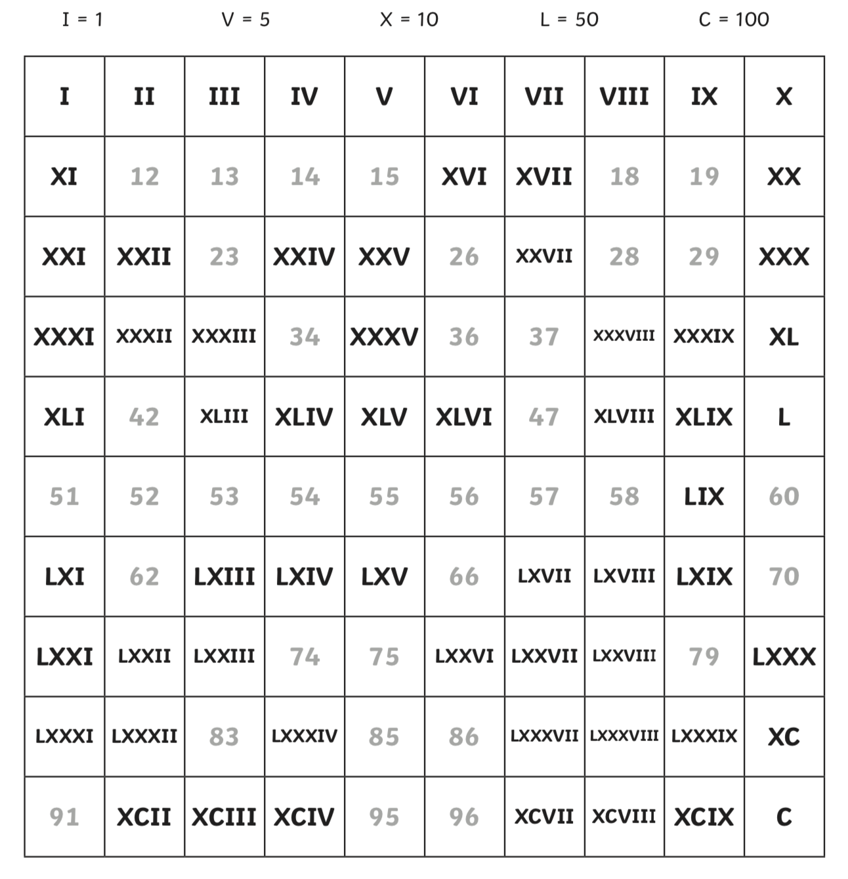

B.
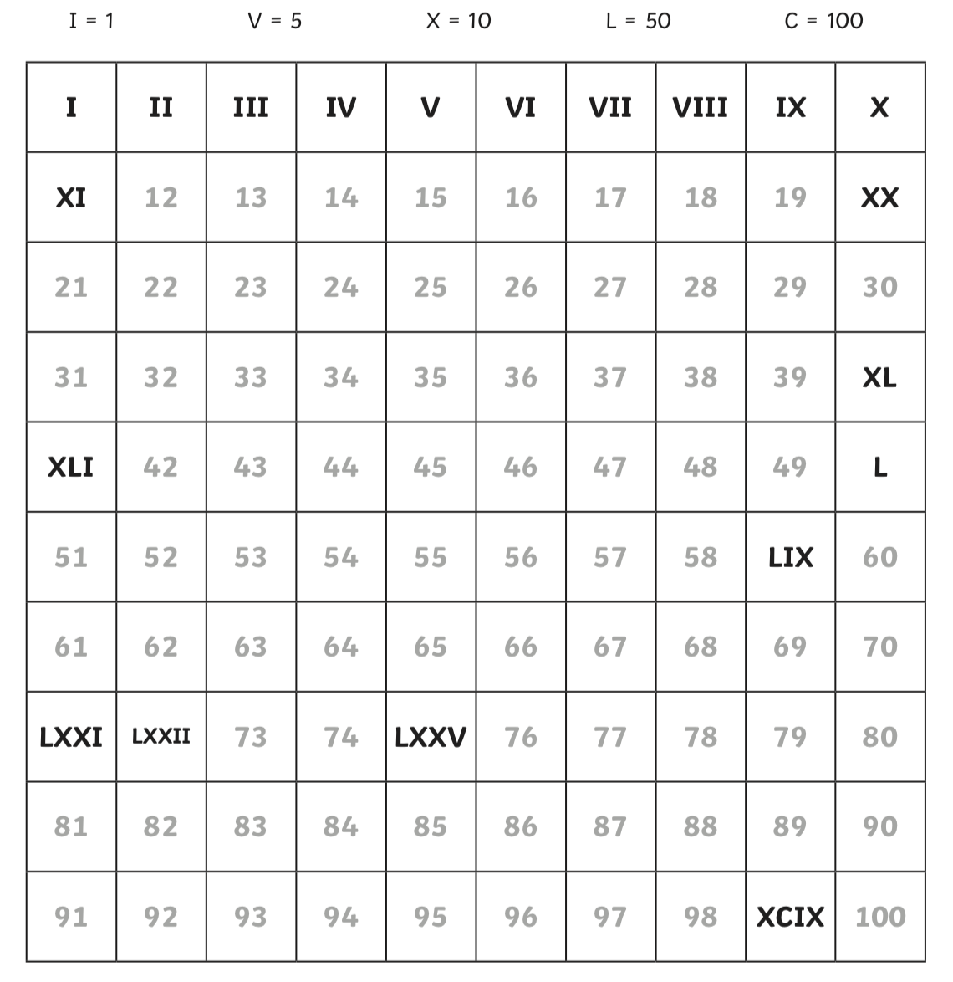

C.

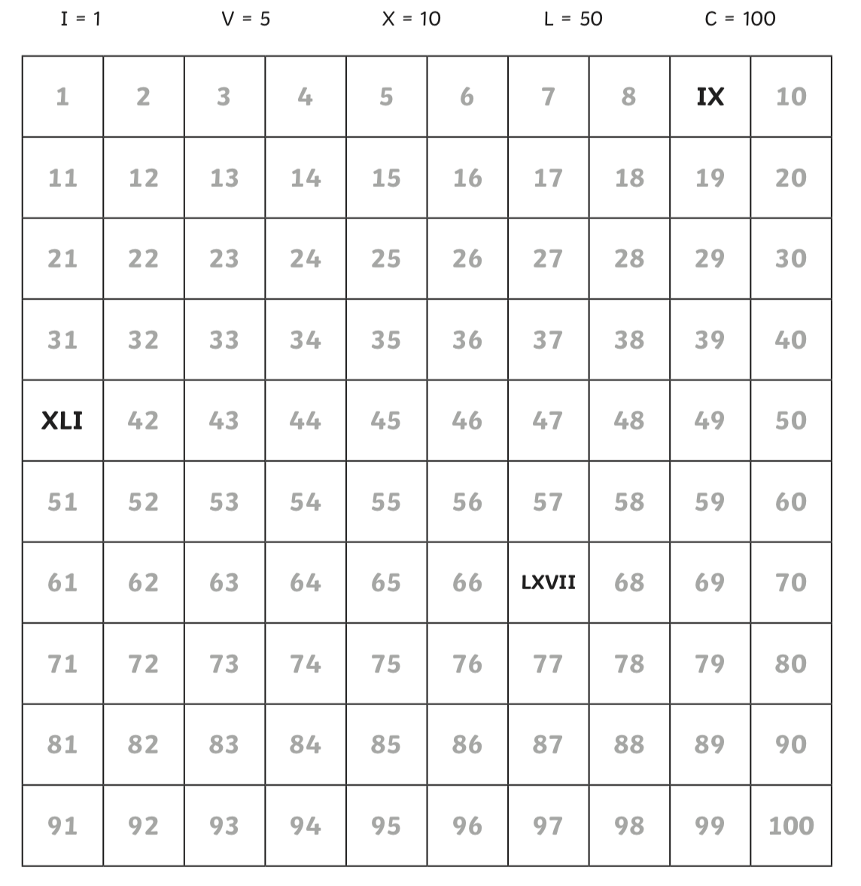

Extension

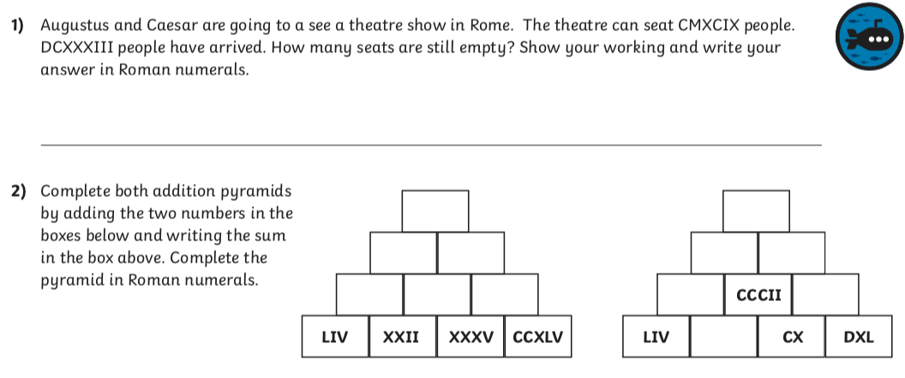

ANSWERS

