III/II/MMXXI
Fractions that are larger than 1.

Please watch the teaching PowerPoint and then have a go at the questions below. We will be going through this in the Teams lesson today. If you can answer the questions from either A, B or C easily then do 5 or 6, check them and if correct answer the challenge questions.

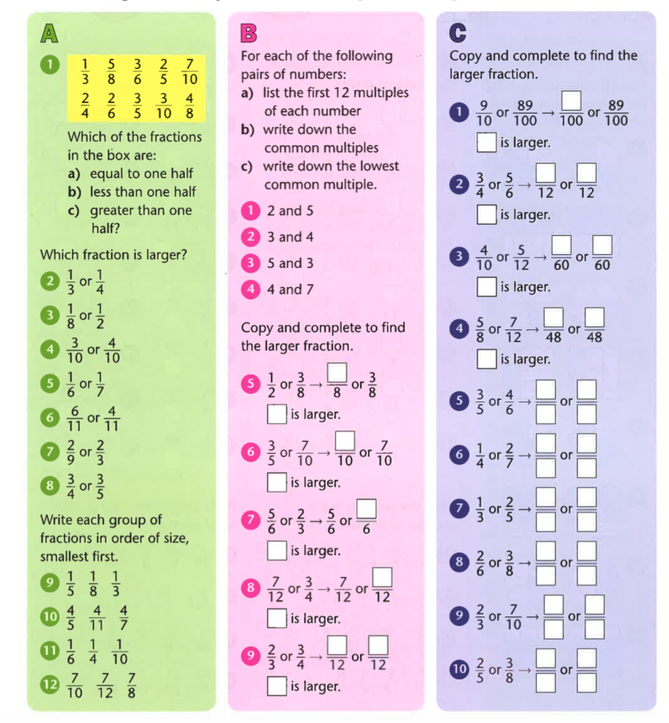

Challenge:

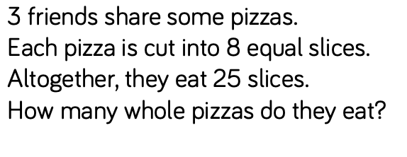

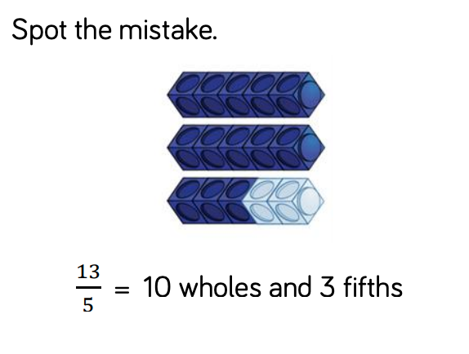

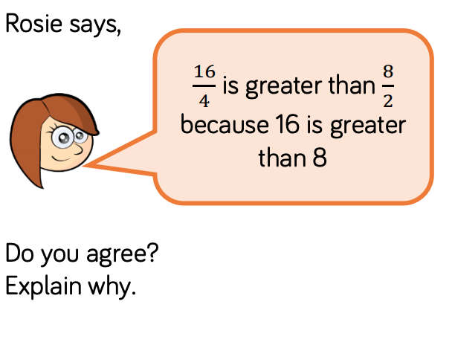

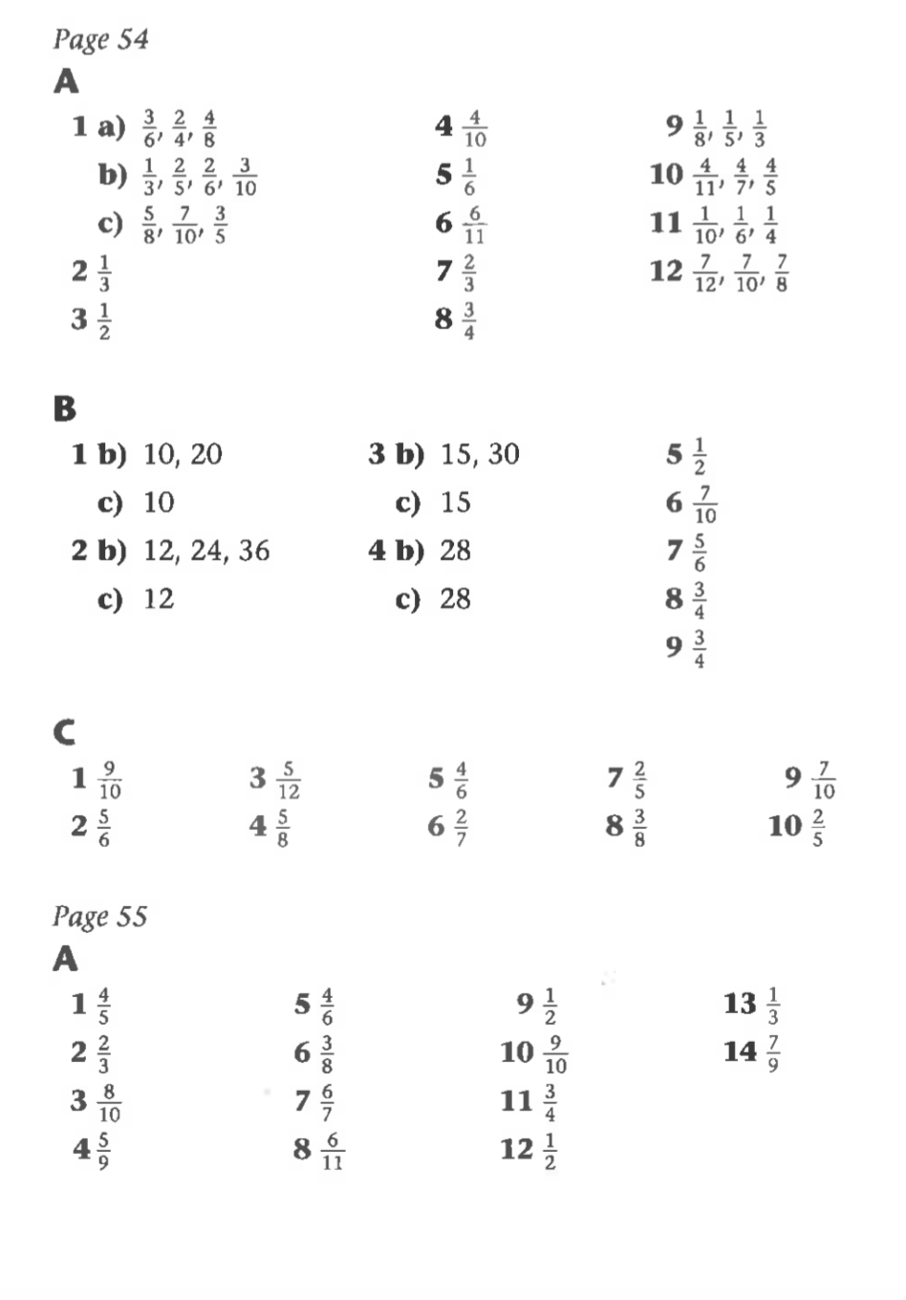

Challenge:
They eat 3 whole pizzas and 1 more slice

There are 2 wholes, not 10. 10/5 = 2 wholes, 13/5 = 2 wholes and 3 fifths.

Disagree because both fractions are equivalent to 4.

