Wednesday 3rd February 2021
PSHE

This week is children’s mental health week. So, I would like you to watch this video https://classroom.thenational.academy/assemblies/childrens-mental-health-week-2021 full of familiar (actors to footballers) faces that encourages everyone to express themselves in a way that’s best for them. There is no right or wrong way to express yourself; it could be through music, art, drama, sport, dance, gardening, fashion and many other ways.

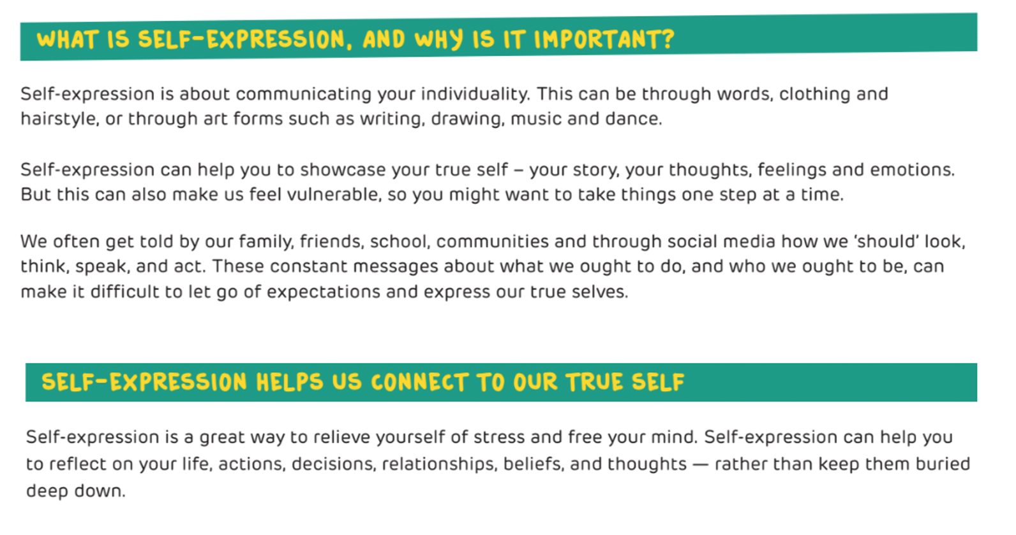

Have a look at the links below and then find a way for you to express yourself. Can you produce a piece of work or short video of you expressing yourself and send it in to me? But you don’t have to, this is a task for you. Enjoy!

Express through art https://youtu.be/5V7SdoSLI1w
Express through dance https://video.link/w/6dbNb
Express yourself through Music https://video.link/w/E9cNb
Now have a listen to these songs https://video.link/w/6rbNb and https://video.link/w/QobNb

