08/02/21 Maths
Counting in Fractions

Today, begin your maths with your times table grid to get that maths brain working. Then have a look through the PowerPoint explaining how to count in fractions then have a go at the questions below. The second B and C are from the year 5 book, so choose the section that you feel confident with.

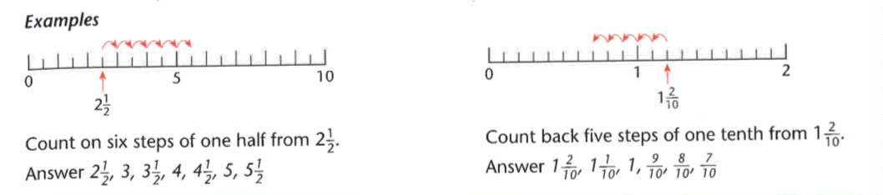

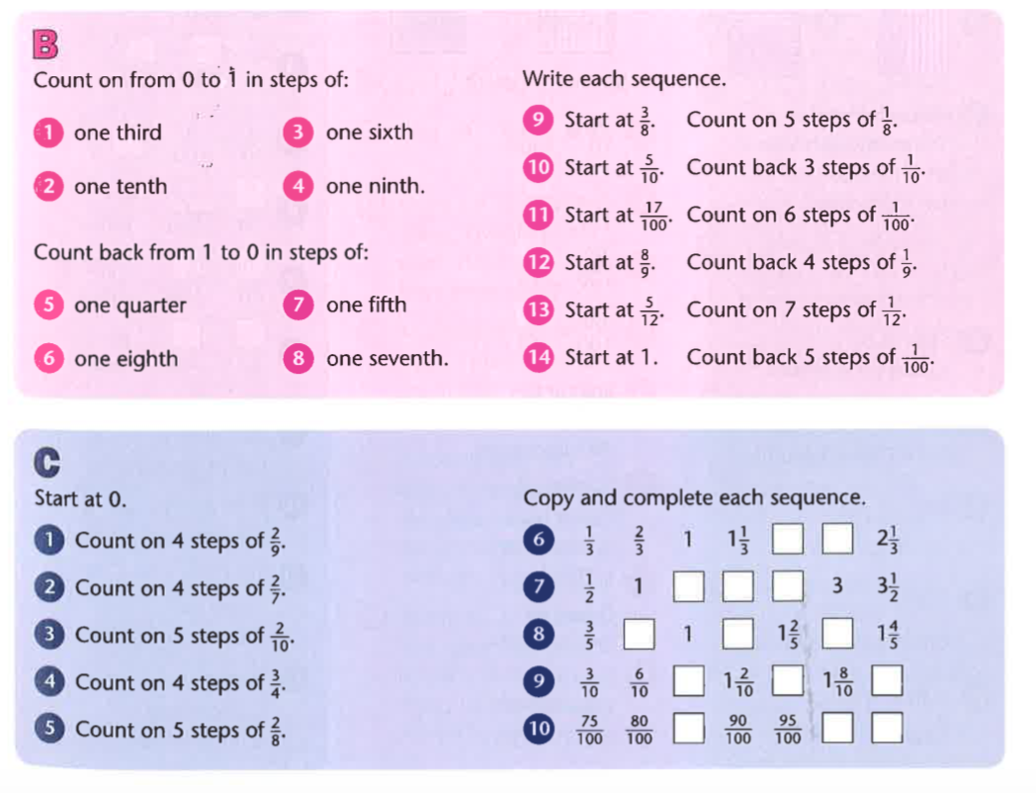
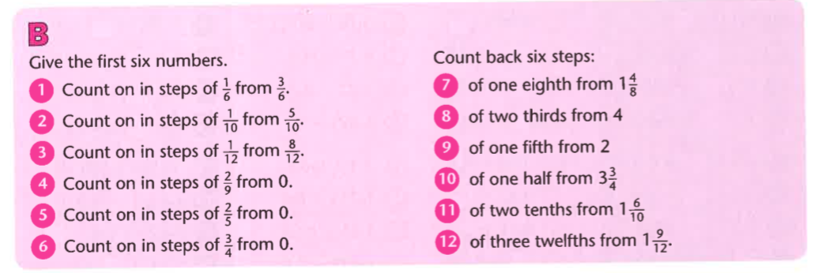
Challenge

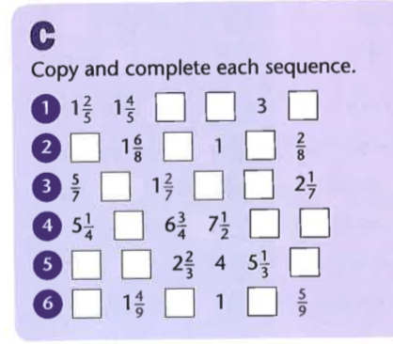

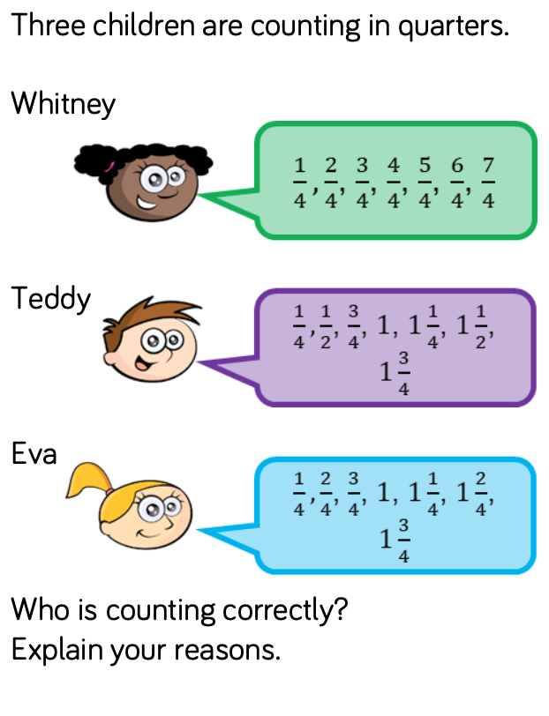

Answers

