**11.02.21**

Today for a starter please complete the following then choose one set of word problems to complete. Remember to underline the important information, write the number sentence then work out your calculations carefully.

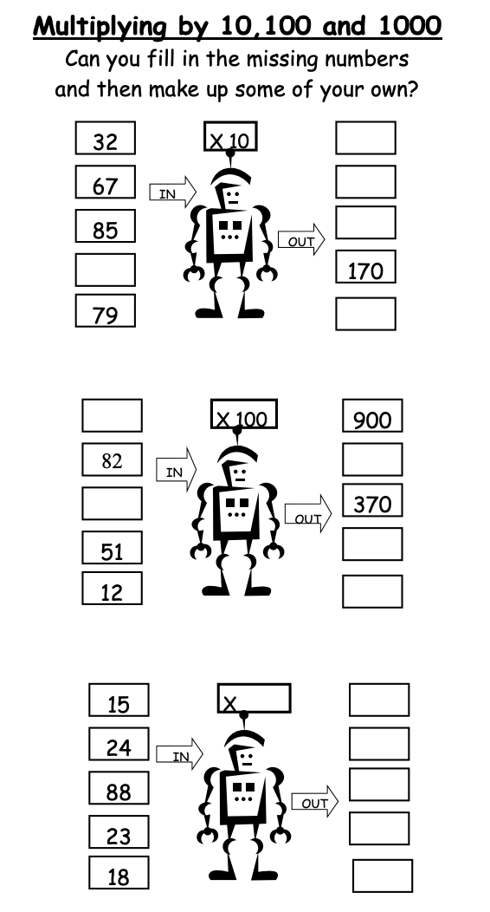

**Solve addition problems using fractions.**

**A**

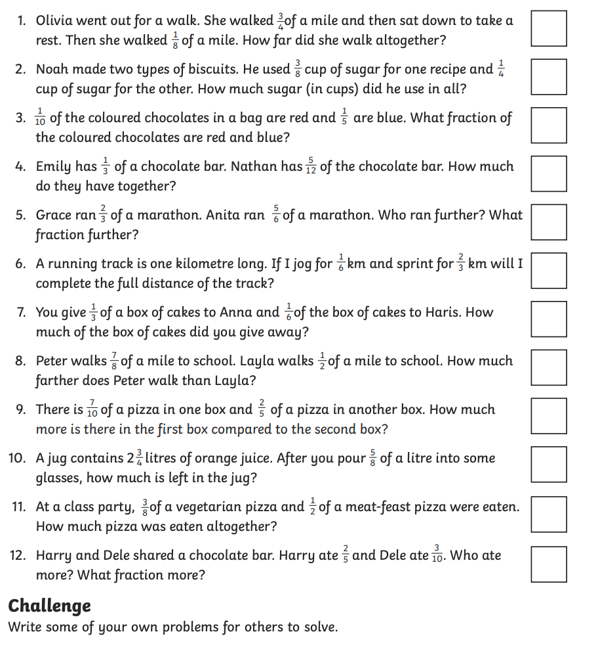

**B**

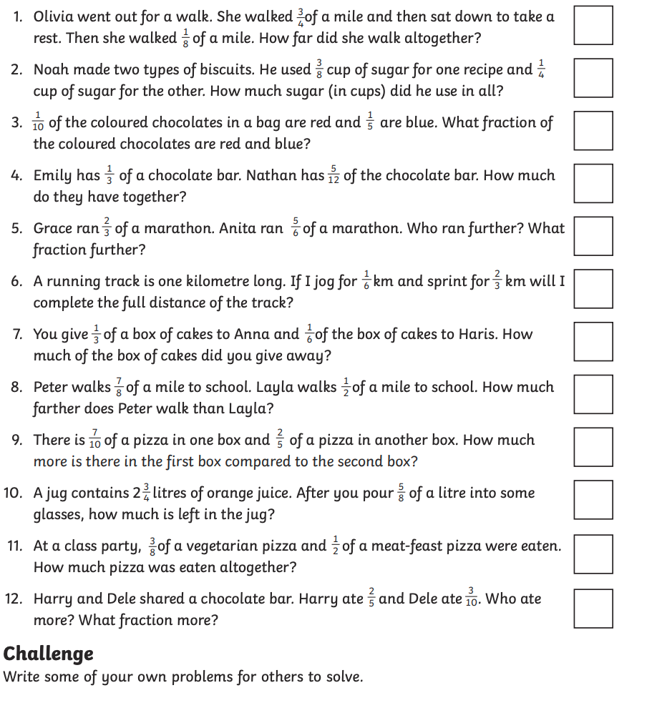

**C**

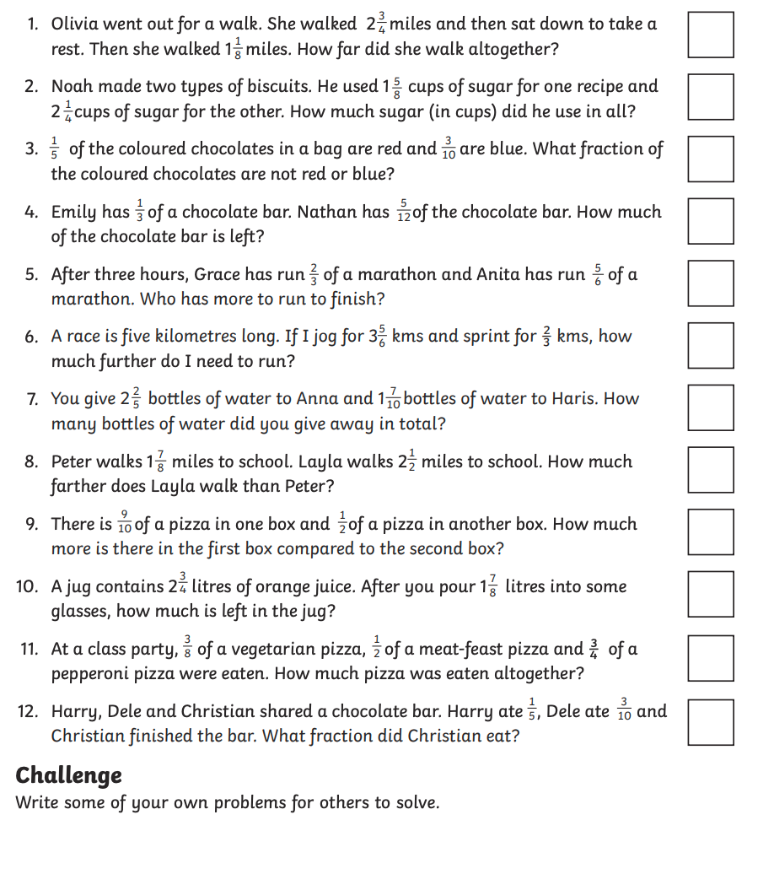

ANSWERS

