09.02.21
To compare and order fractions

Have a look through the PowerPoint and then answer the questions in A, B or C. If you are confident then have a go at today’s challenge and see if you can escape the Harry Potter themed escape room. Read the clues carefully and you’ll soon be free! Enjoy.

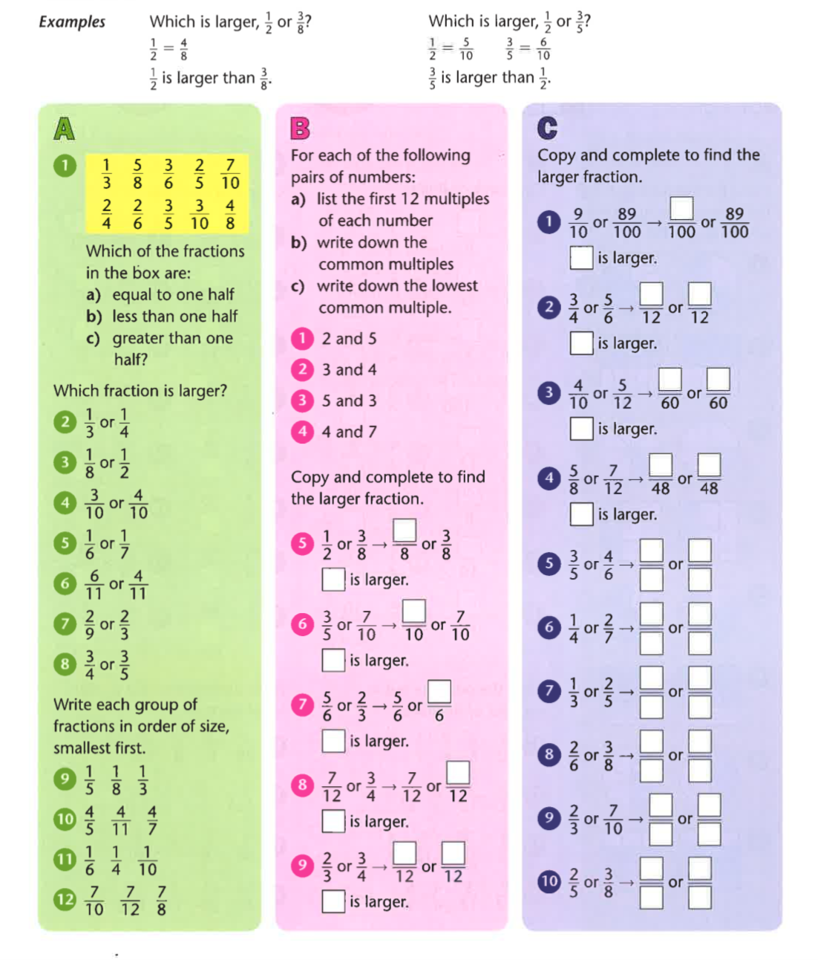

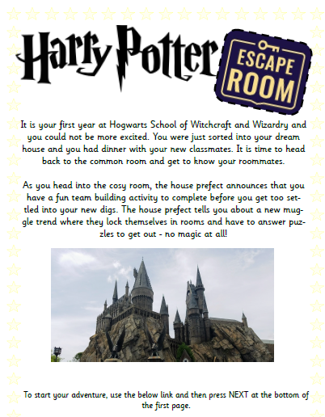

Challenge

https://docs.google.com/forms/d/e/1FAIpQLSflNxNM0jzbZJjUqOcXkwhGTfii4CM_CA3kCxImbY8c3AABEA/viewform

