Tuesday 9th February 2021
English and Topic

You should have done a bit of research about your chosen person. Now you need to begin to turn it in to a fact file. So take 2 sheets of A4. Put them in front of you landscape, fold them in half then hole punch the folded edge. Tie some string or wool through the holes to make a mini book.

On your first page I’d like you to design a front cover. This could include the name of the person you are researching and a picture or lots of pictures of them. Then you will need to think of a few quotes or rhetorical questions to entice people to read your fact file. For example, you might write of Mo Farah, Open me to find out more about the most talented runner the world has ever seen. Remember this is persuasive writing so remember those bossy verbs! You can use the computer then cut out, use different colour pens, whatever you choose take care with your presentation.

The next page will include facts about your person. For this you will need to use lined paper for your writing, but leave a space for a small picture or two. You must include your person’s full name, country they were born in, country they moved to, what age they were when they moved. This is topic so it would be ideal if you could show on a world map where both countries are and estimate how far they travelled. Again, concentrate on presentation. Use headings and subheadings so the information is easy to find for your reader.

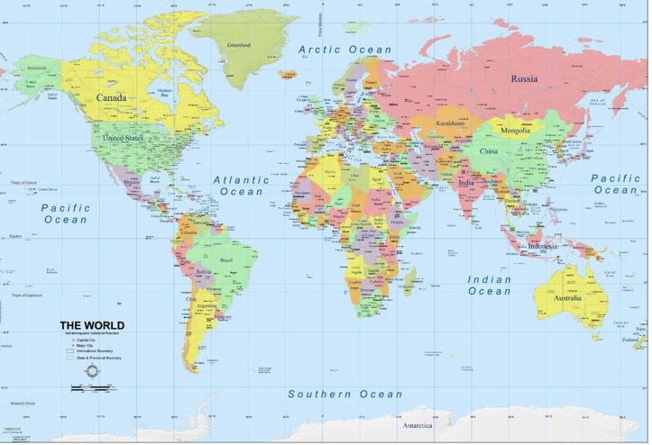
We will chat about this and have time to sort this out in our Teams Topic lesson this afternoon.

