10.02.21

To add and subtract fractions.

As a warm up follow this link to do a quick fractions quiz!
https://www.educationquizzes.com/ks2/maths/fractions-year-5/

Have another look through the power point. Try to make sure you understand how to compare fractions. We will be going back over this again as it is rather tricky! As usual, choose from A, B or C and then have a go at the challenges.

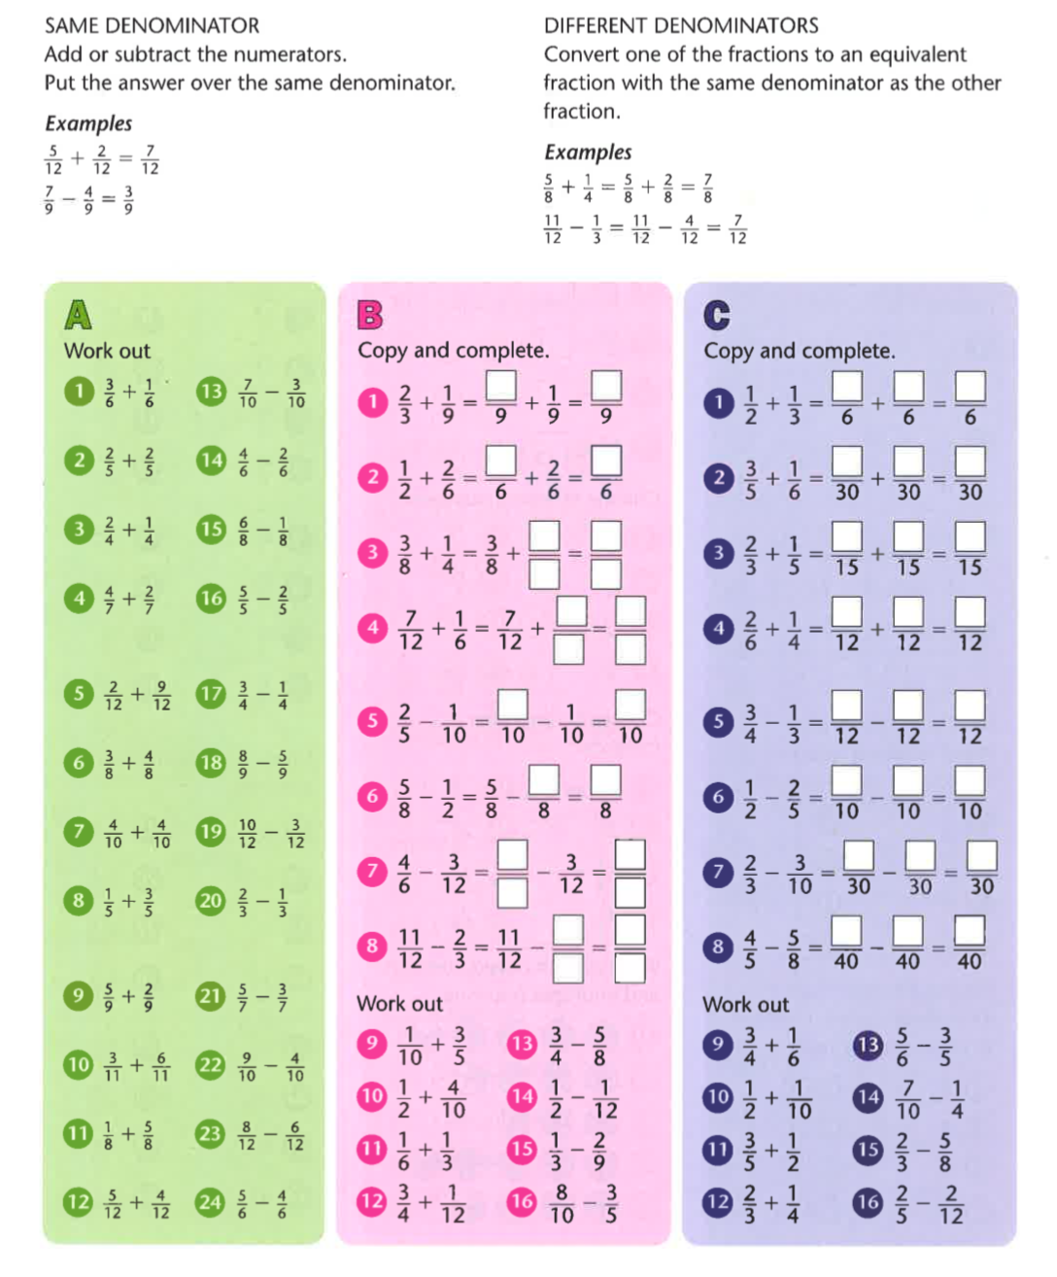

Challenges

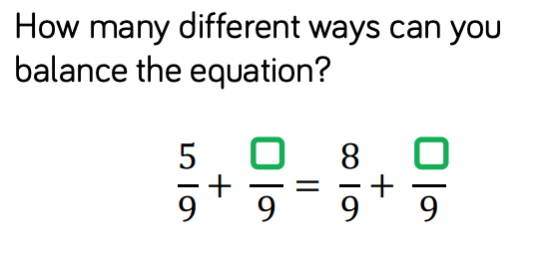

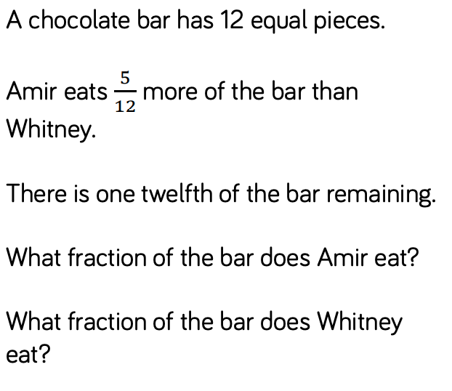

ANSWERS

