Can yoCaCCanlkdc/ldkmnlk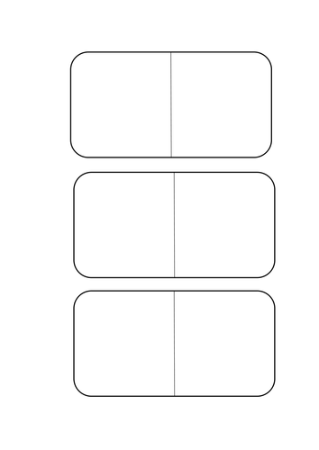
Draw, paint or colour the spots on the dominoes.
Make sure there are only 6 in total. How many are there on each side?

