Semi colon and colon practice
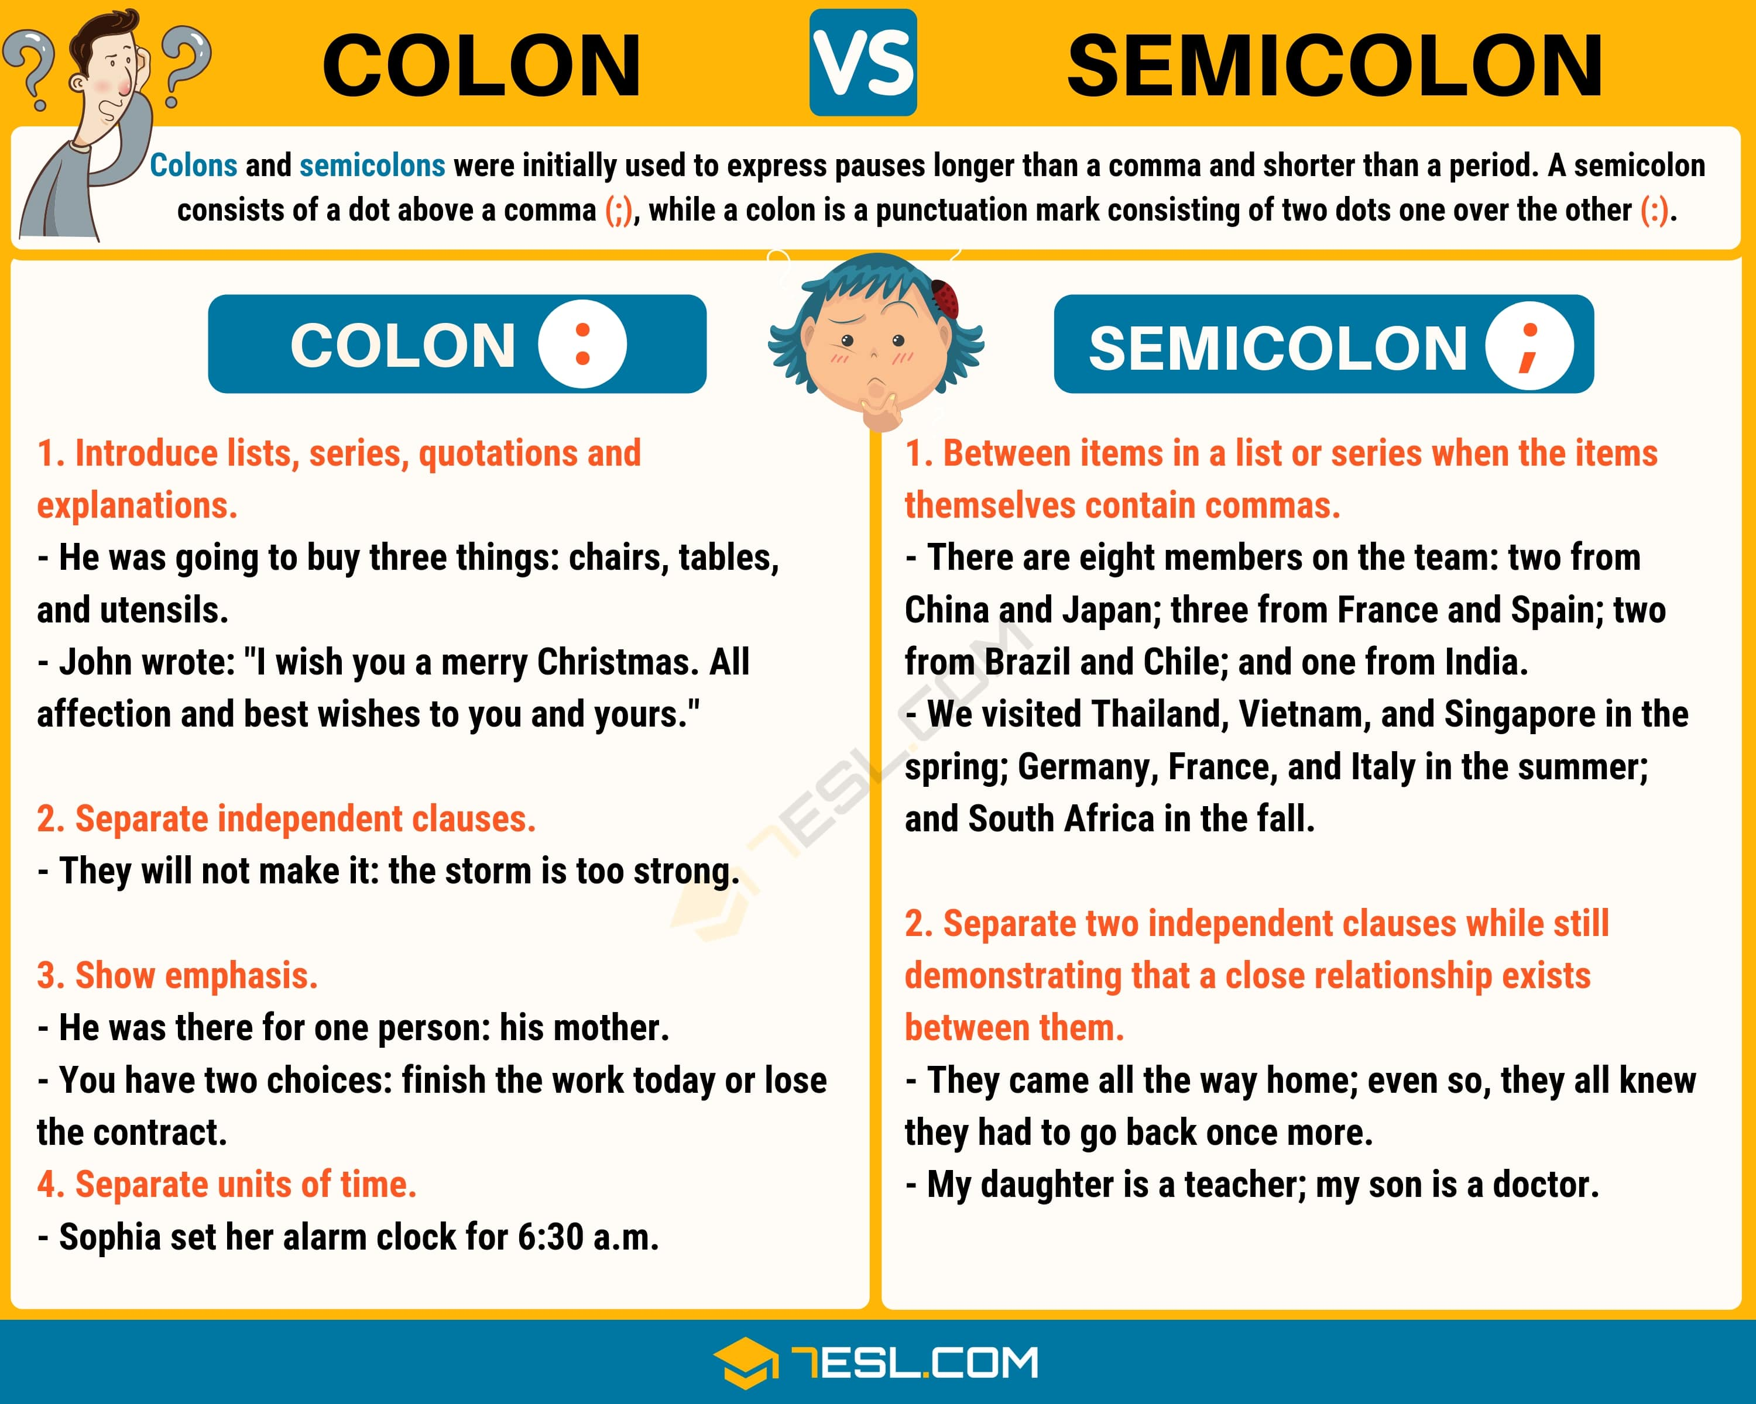
- The coach told the players to do one thing to have fun while playing.
- The game is always exciting the crowd gets really involved.
- The kids came up with cool superhero names and matching titles including Marvoman, Defender of the Universe BrilliaWoman, Protector of the World AquaGoddess, Matron of the Sea and TerraMan, Keeper of the Earth.
- What word do you need to delete from sentence 3 in order to use a colon?
- I like to swim in the ocean every morning the cold water wakes me up.
- I know the key ingredient to delicious curries high-quality meat and fresh cumin.
- If the odds were 25:1 there was just one thing left for Dale to do place a bet
- Red wine goes well with red meats and hearty sauces white wine is better for chicken, fish, and delicate sauces.

Semi colon and colon practice

- The coach told the players to do one thing to have fun while playing.
- The game is always exciting the crowd gets really involved.
- The kids came up with cool superhero names and matching titles including Marvoman, Defender of the Universe BrilliaWoman, Protector of the World AquaGoddess, Matron of the Sea and TerraMan, Keeper of the Earth.
- What word do you need to delete from sentence 3 in order to use a colon?
- I like to swim in the ocean every morning the cold water wakes me up.
- I know the key ingredient to delicious curries high-quality meat and fresh cumin.
- If the odds were 25:1 there was just one thing left for Dale to do place a bet
- Red wine goes well with red meats and hearty sauces white wine is better for chicken, fish, and delicate sauces.

