Topic and Art 5th February

First of all watch the clip and read the article on [What is evolution? - BBC Bitesize](https://www.bbc.co.uk/bitesize/topics/zvhhvcw/articles/z9qs4qt) Then follow the Powerpoint attached.

Once you have read both of those, I would like you to write at least 2 paragraphs in your own words on what you think Charles Darwin believed evolution to be.

Try to use as many of the following terms in your paragraphs (and explain them)

* **Adaptation**
* **Evolution**
* **Inheritance**
* **Species**
* **Variation**

Also use examples of certain animals in your paragraphs– you can use the giraffe example used in the power point or research this further and use what you find. I would like after your paragraphs to show the evolution of an animal through drawings and sketching: how it originally looked and how it has evolved over time. *This is your art activity for the day.*

*Here is an example and feel free to add some annotation to your drawing.*

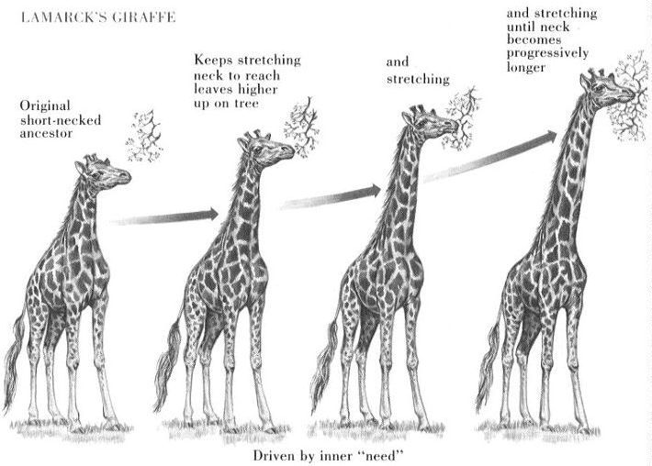

Please send your work to Mr Bird – headteacher@charing.kent.sch.uk