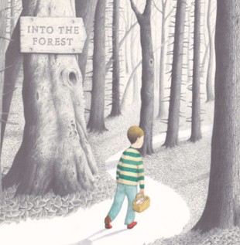**Please send your completed work to** [**lhumphries@charing.kent.sch.uk**](mailto:lhumphries@charing.kent.sch.uk) **or upload it onto Teams.**

**English**

This term, we will be reading the story *Into the Forest* by Anthony Browne.

You can listen to this story being read on the following link:

<https://www.youtube.com/watch?v=qjgugbdwvMY>

Read the next page in the story.

Questions to think about

Where might Dad have gone?

What might Mum be thinking?

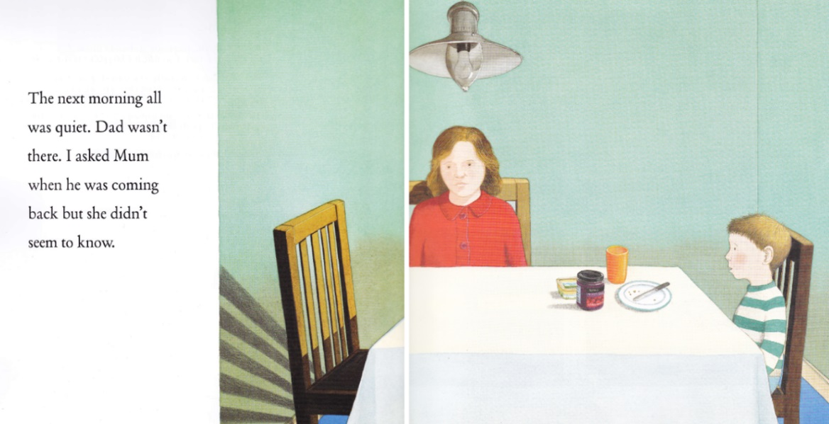What might the boy be thinking?

Writing Task

With an adult at home, role play the conversation that Mum and the boy could have or in your mind, imagine what conversation they could have. Once you have done this, write down a conversation between Mum and the boy. You can use inverted commas for speech to do this. You can read through the PowerPoint presentation for inverted commas for speech. You can also use the poster in the resources section if you need to refresh your memory on the correct punctation. Try and use an alternative word to ‘said’ by choosing a word from the list below.

“Where is Dad?” _________ the boy.

“I don’t know where he is,” __________ Mum. “I am sure that he will be back soon,” Mum added.

“_____________________________________________!” sighed the boy.

“_____________________________________________” _____________.

Challenge

Imagine that a new character was sat at the table with Mum and the boy. Can you include an additional character to the conversation?

Resources

