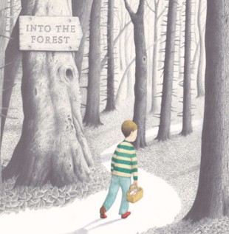**Please send your completed work to** [**lhumphries@charing.kent.sch.uk**](mailto:lhumphries@charing.kent.sch.uk) **or upload it onto Teams.**

**English**

This term, we will be reading the story *Into the Forest* by Anthony Browne.

You can listen to this story being read on the following link:

<https://www.youtube.com/watch?v=qjgugbdwvMY>

Read the next page in the story.

Questions to think about

How do you think Mum is feeling and how do you know this?

How is the boy feeling and how do you know this?

Why did the boy ask about Dad coming home?

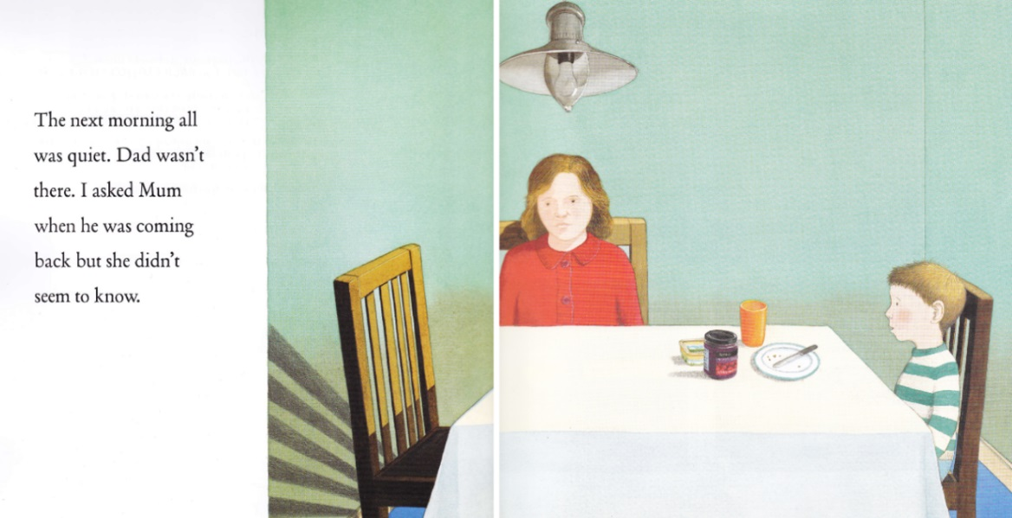

Writing Task

In role as the boy, write a note to Dad to describe how the boy is feeling about his dad’s whereabouts. You will need to write in the first person and include how the boy is feeling and why.

Complete the sentences below.

Example

To Dad,

I am writing this note because I am feeling extremely _________. I asked Mum when you were coming home. She said___________________________ . I really miss you Dad! I want you to come home because…

When you come home, we will play…

I hope to see you soon,

Love from your dearest Son

Challenge

Can you include a question?

Resources

