Foxes Homework
Date set: 12/3/21
Date due: 19/3/21

Spellings - Test 19/3/21
across
after
again
air
along
creaked
tangled
creeped
rustled
stumbled

Maths

Choose set A or B

Set A
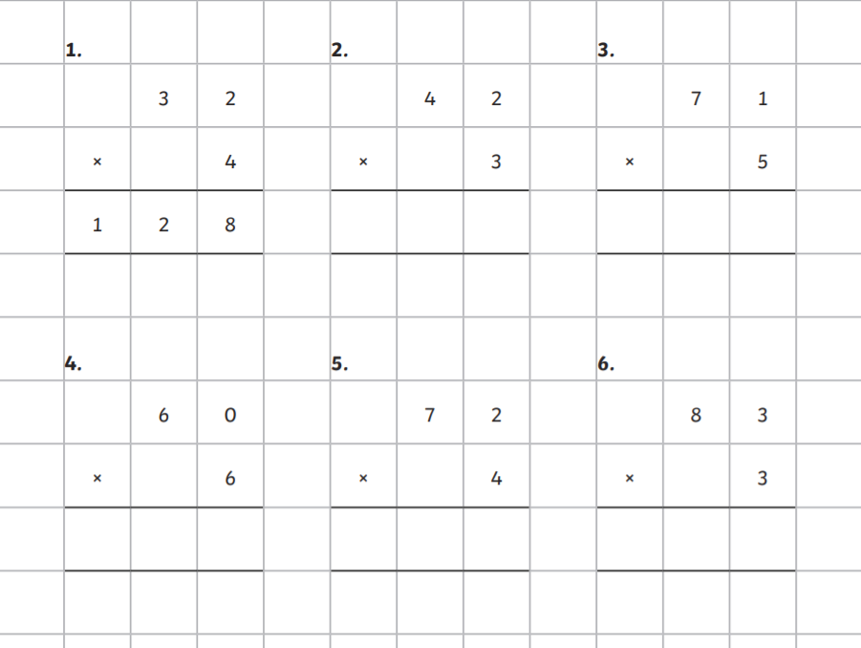

Set B
