Foxes Homework
Date set: 12/3/21
Date due: 19/3/21

Spellings - Test 19/3/21
the
that
not
look
put
and
with
then
don’t
could

Maths

Choose set A or B

Set A
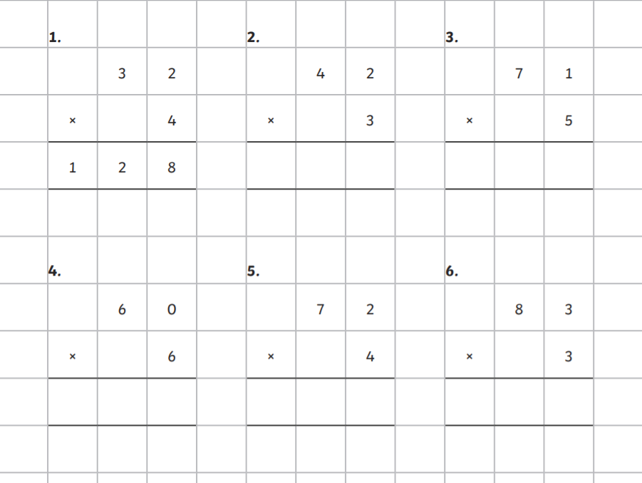

Set B
