Foxes Homework

Spellings - Test 1/4/21
the
that
not
look
put
and
with
then
don’t
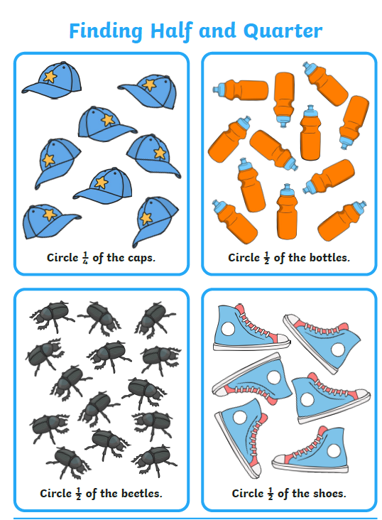
could
Maths

