A:

Use the bus stop method to work out the answers to the following:
Remember to divide the number in the 10s column first, carry any remainders on to the 1s column just as you would for any other calculation.

1. 26÷2= 2. 36÷3= 3. 84÷4= 4. 46÷2= 5. 69÷3=
6. 65÷5 = 7. 54÷3= 8. 64÷4= 9. 78÷2= 10. 100÷2=

B.

Use the bus stop method. Some of these will have remainders (left over sweets for the rabbit).

1. 75÷5= 2. 96÷3= 3. 144÷6= 4. 378÷2= 5. 351÷3=
6. 141÷2= 7. 762÷5= 8. 377÷6= 9. 653÷5= 10. 1431÷3=

C:

These are investigations, for the first question there will be more than one correct answer. You will need to prove to me that your answer works and how you know you are correct.

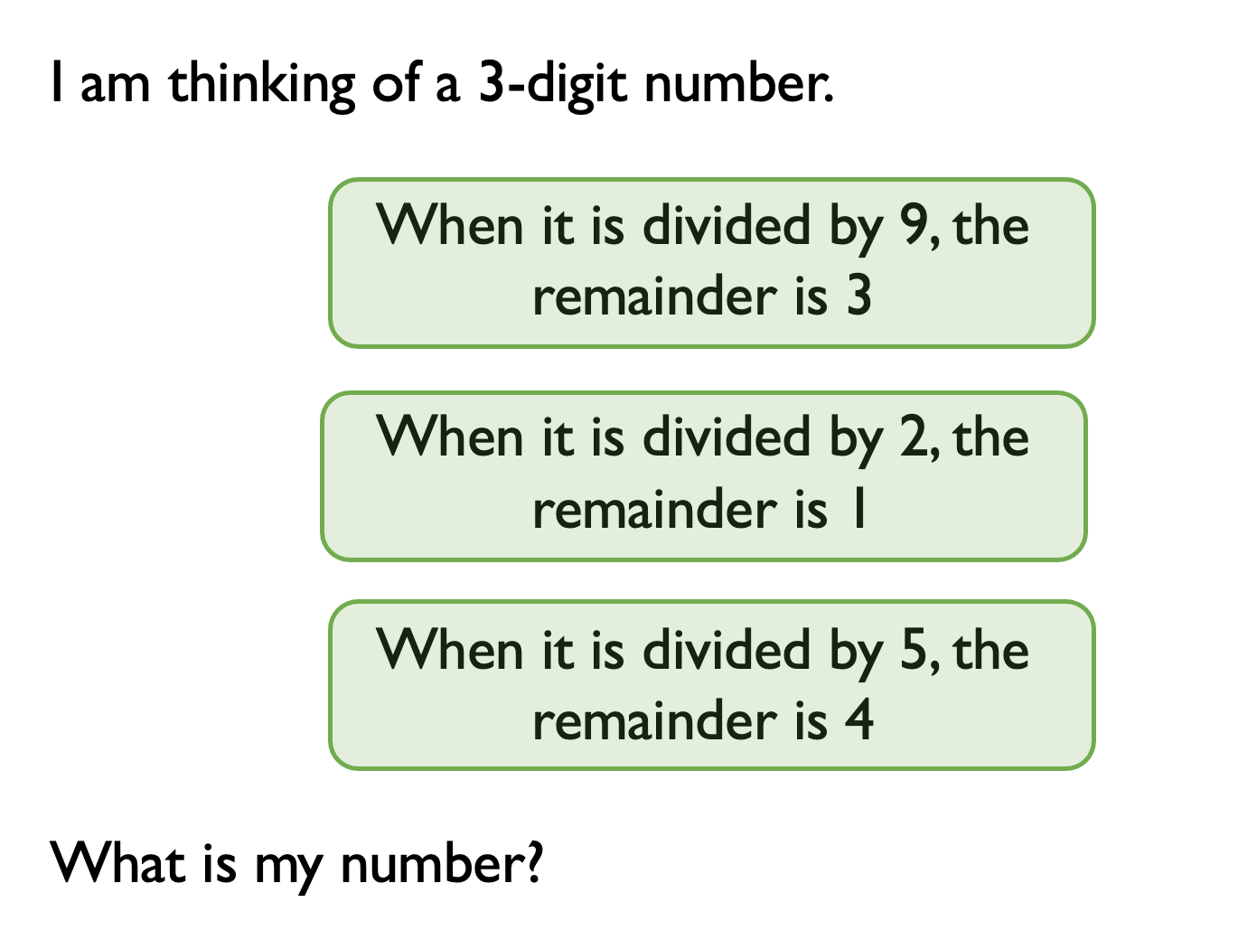

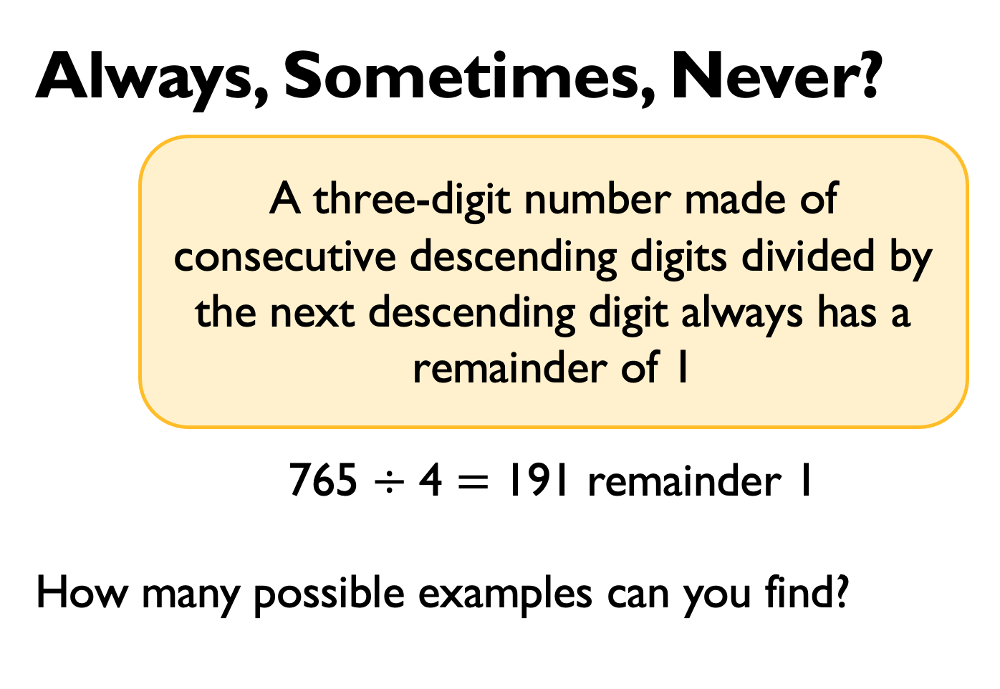

ENGLISH

Please find and correct my 10 mistakes. Ext – write 5 interesting facts about WW2 in a beautiful paragraph.

In september 1939, the German armey invaded Poland. Adolf hitler craved revenge for his country’s deafeat in World War One around 1.5 million German soldgers stormed into Poland armed with machine guns grenades and powerfull field guns. Adolf Hitler planed to build a new empire for germany – and to do it by forse.

