Practice writing these words.

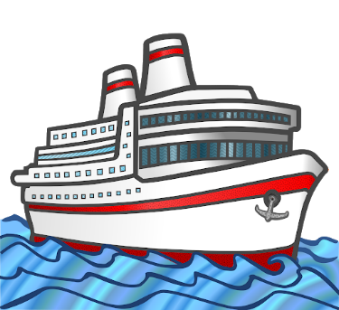

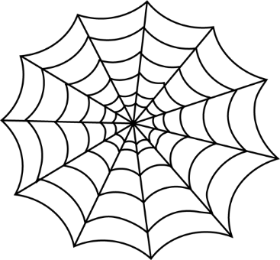

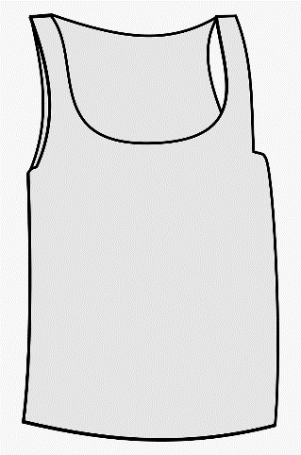

Now write a silly sentence!

_____________________________________________________________________________