Rabbits Home Learning
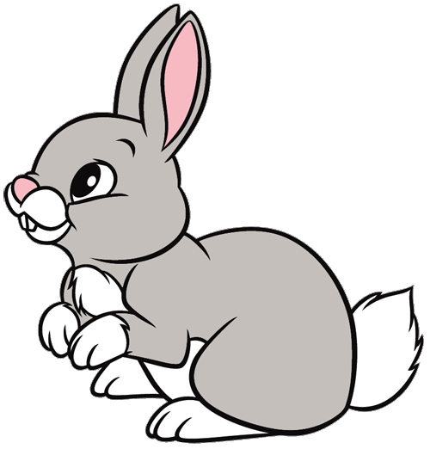
Monday 1st March
English
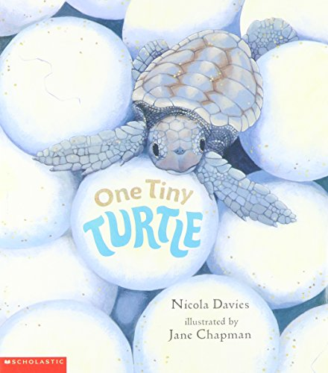
https://www.youtube.com/watch?v=kVEDG1jooyE

What do you remember about the turtle?
Can you tell an adult 3 facts about the turtle?

Make a turtle using bubble wrap to make the pattern on the shell (or use the pdf attached).
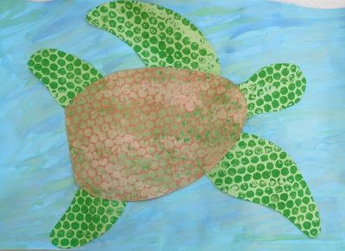

RWI
Practise your th and ng sounds.
Sheets attached.

Maths
Compare the height of your toys!
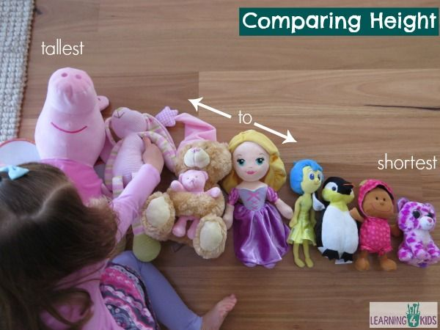
Which is the tallest and which is the shortest?
Can you put them in height order?
There is another activity attached too.

https://www.youtube.com/watch?v=SBny_0RbVuc
Here is an Octonauts episode about Sandy the sea turtle. Enjoy!

