Rabbits Home Learning
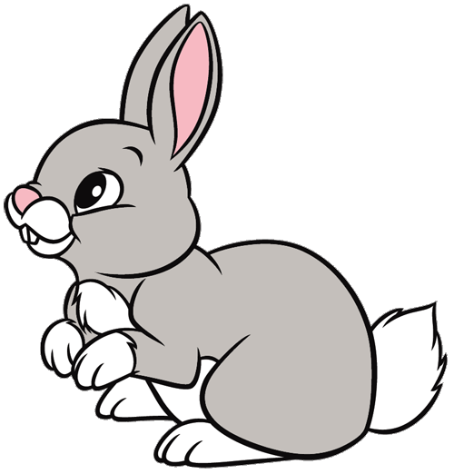
Monday 1st March
English

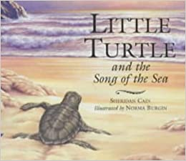
Make your own picture of the baby turtle on the beach.
Make sure you include the sand, the sea, the sun and the other creatures on the beach.

RWI
Today Miss Reeve helped you practice your nk sound.
Can you find and draw three things which are pink?
Can you write the words too?

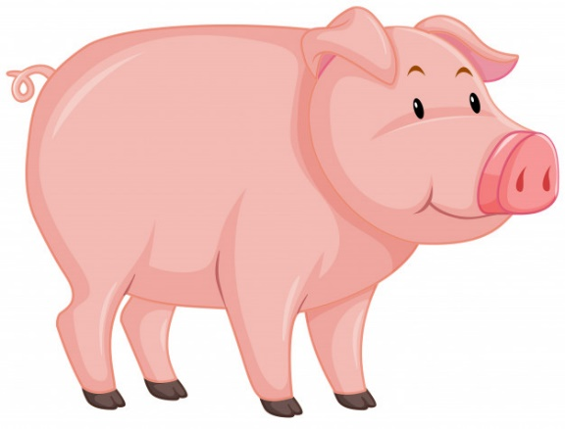

Maths
Please use the attached pdf activity based on today’s lesson.

https://www.youtube.com/watch?v=e-HfR77J0W0
Here is another Octonauts episode about turtles, this time it’s baby sea turtles!

