Rabbits Home Learning
Wednesday 3rd March
Octonauts
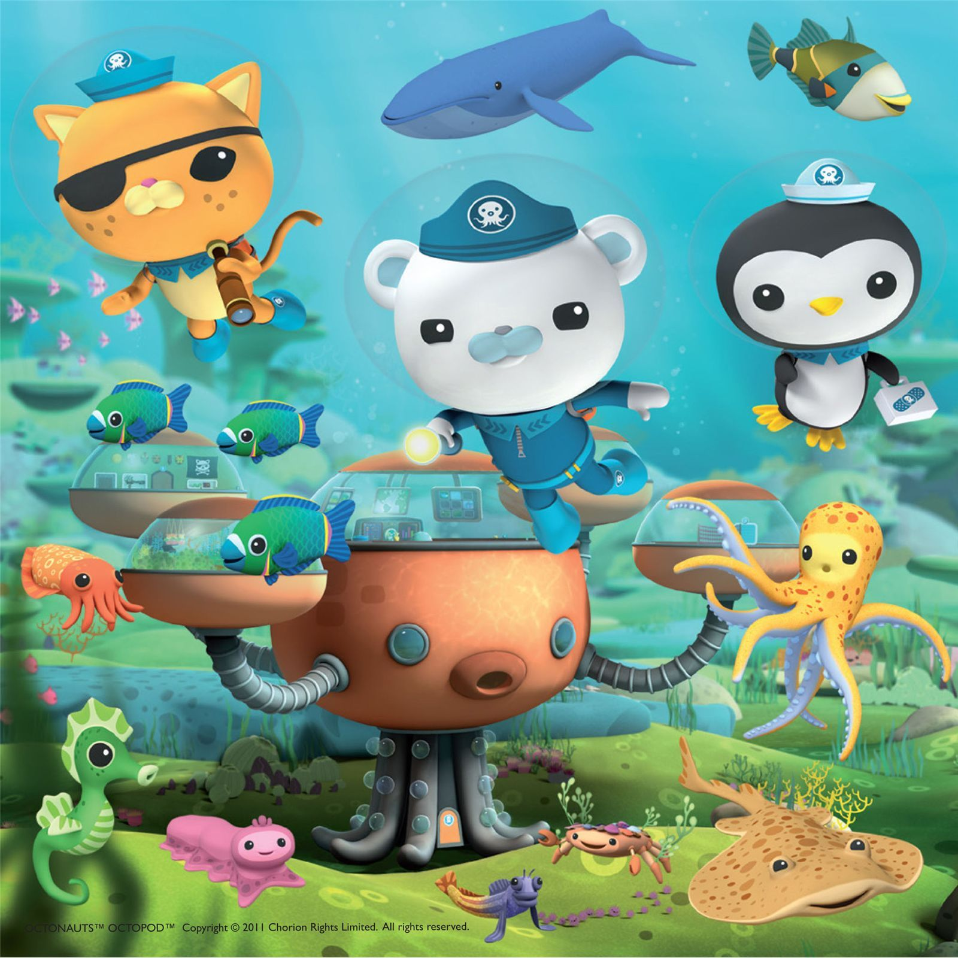
http://www.octonauts.com/
Explore the octonauts website.

RWI

Maths
Please use the attached pdf activity based on today’s lesson.

https://www.youtube.com/watch?v=e-HfR77J0W0
Here is another Octonauts episode about turtles, this time it’s baby sea turtles!

