Rabbits Home Learning
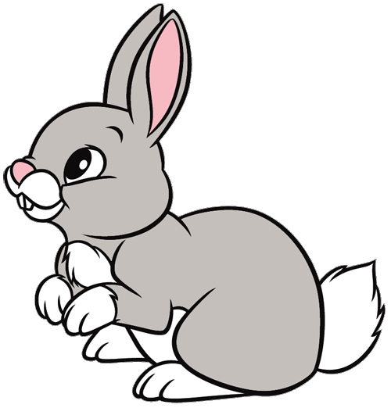
Friday 4th March

Outdoor Learning
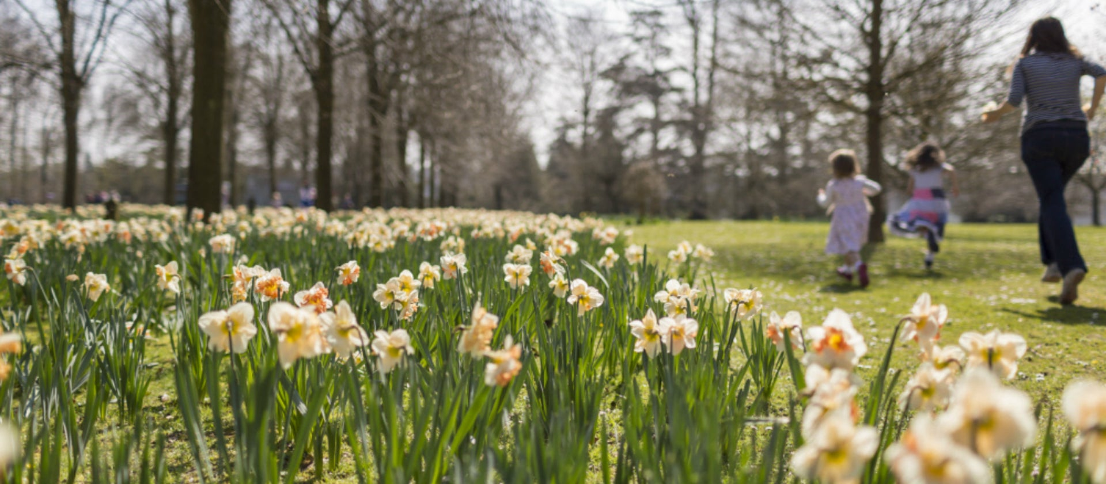
Enjoy this last Friday at home with your families. Go for a walk, play outside, ride a bike or scooter or build a den outside.
If you have time, try some of the outdoor learning challenges attached.

See you all on Monday!
We are really looking forward to seeing you all on Monday.
Make sure you check that your school uniform still fits you…. And don’t forget your water bottle.

Mrs Golden

