Rabbits Home Learning

Next week we are reading a book about boats.
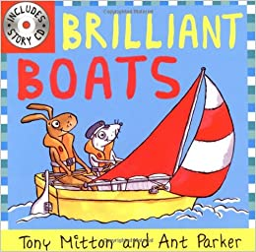
Design your own flag for a boat using the template attached or make your own.
Can you make a small boat at home to bring into school next week?
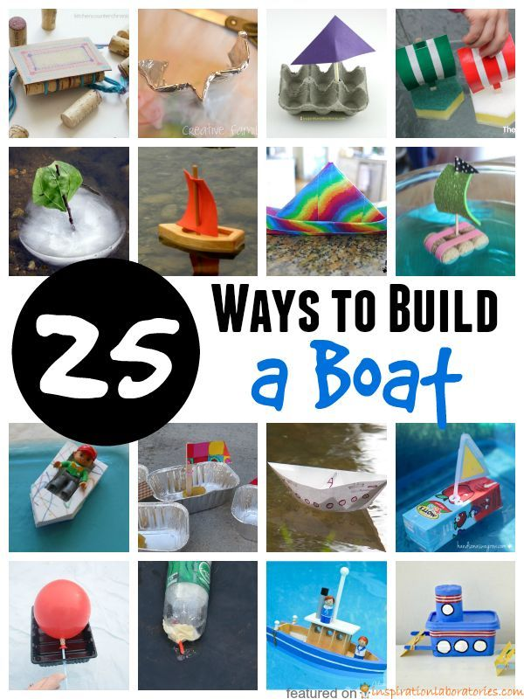
Can you recycle some old junk and use it to make your boat? If you go near the sea this weekend and you see any boats, take some photos and send them to me please.
rgolden@charing.kent.sch.uk
What do you think the boat is used for?

There is also some counting for you to do too!

Have a lovely weekend.
Mrs Golden, Mrs Nunn and Miss Reeve

