Rabbits Home Learning
Thank you for the amazing boats you sent in!
Please bring in all remaining aquariums on Monday. We will be inviting Mr Bird to come and see them.

This week in Maths we have been looking at 10 frames.
Can you make a 10 frame inside or draw one outside with chalk?
Encourage your child to fill the 10 frame with items. Can they quickly tell you if they have put 5 in, or 6 or 9?
The idea is to get the children to recognise amounts quickly without always having to start counting from 1 every time.

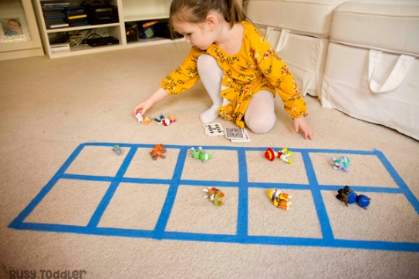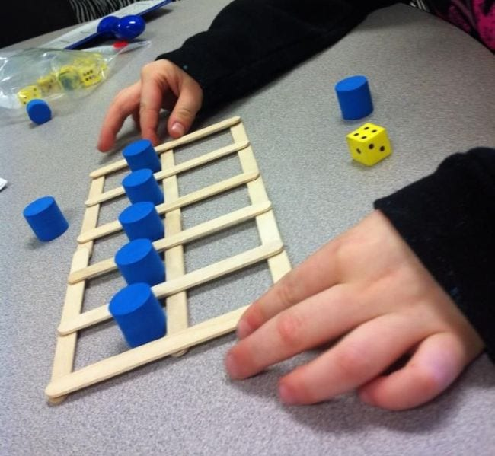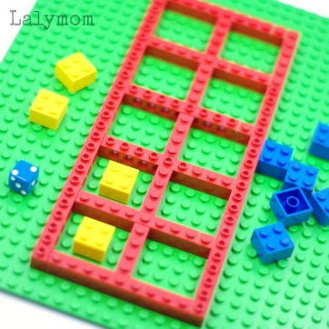
This week’s sounds in RWI are…
sh v w
A revision for some children but a new sound for some.
Please find the practice sheet in here.
We will only be having one home learning book from now on.
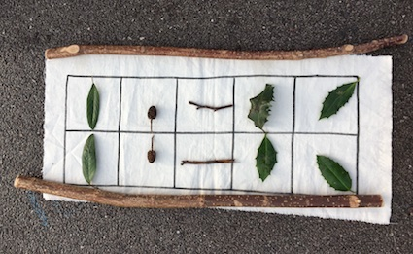

Have a lovely weekend.
Mrs Golden, Mrs Nunn and Miss Reeve

