Welcome back Rabbits!
This term we are continuing to find out about ‘Under the Sea’ and sea creatures.
Make you own under water scene!

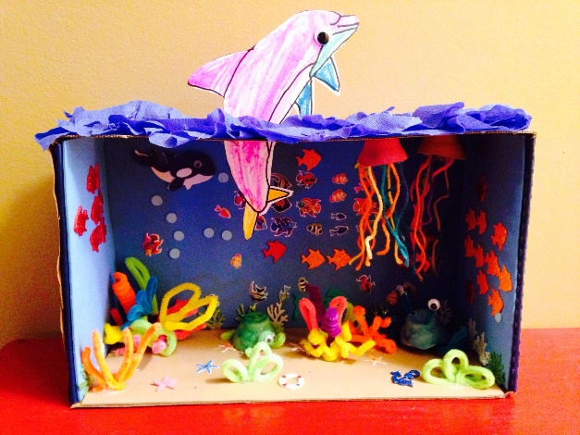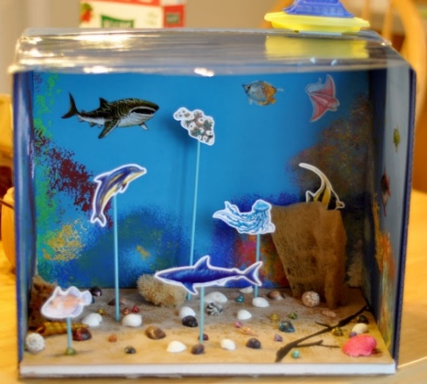
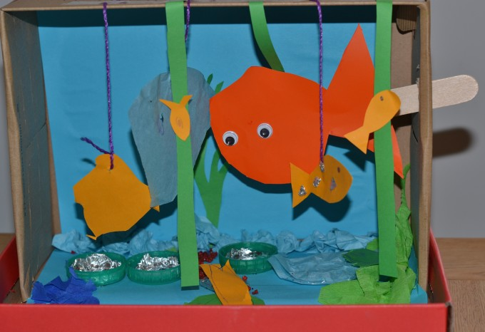
Please bring these to school by Monday 29th March, the last week of term.
If you didn’t access the home learning during school closure, this is your home learning project for this term.

This term we are going to begin to use the ICT suite on a Friday. We are going to be learning how to use and control the mouse to interact with different activities on the screen and using the keyboard to type in our logins.
Week 1: Exploring mini mash and playing pairs to introduce the correct move button to use.
Week 2/3: Using 2paint to create a sea creature picture/ underwater scene and develop mouse control.
Please find attached your child’s username, password should you wish to log on and practise at home. There is also a parent code for you to use to see what they have been creating.
Mrs Golden, Miss Reeve and Mrs Nunn

