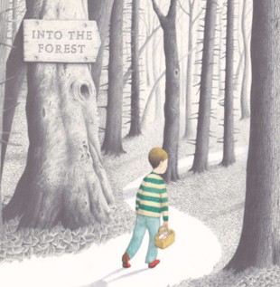
Please send your completed work to lhumphries@charing.kent.sch.uk or upload it onto Teams.
English
This term, we will be reading the story Into the Forest by Anthony Browne.
You can listen to this story being read on the following link:
https://www.youtube.com/watch?v=qjgugbdwvMY

Read the next page in the story and answer the following questions.
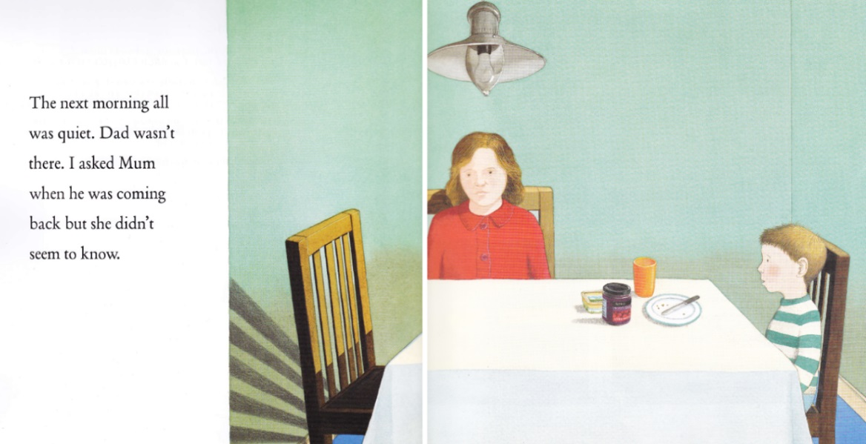

- Is Mum happy or sad? How do you know this?
- How is the boy feeling?
- What do you think the boy should do about his dad?
- Have you ever felt worried? Why?

