Spellings – (Mrs Siddiqui’s group)
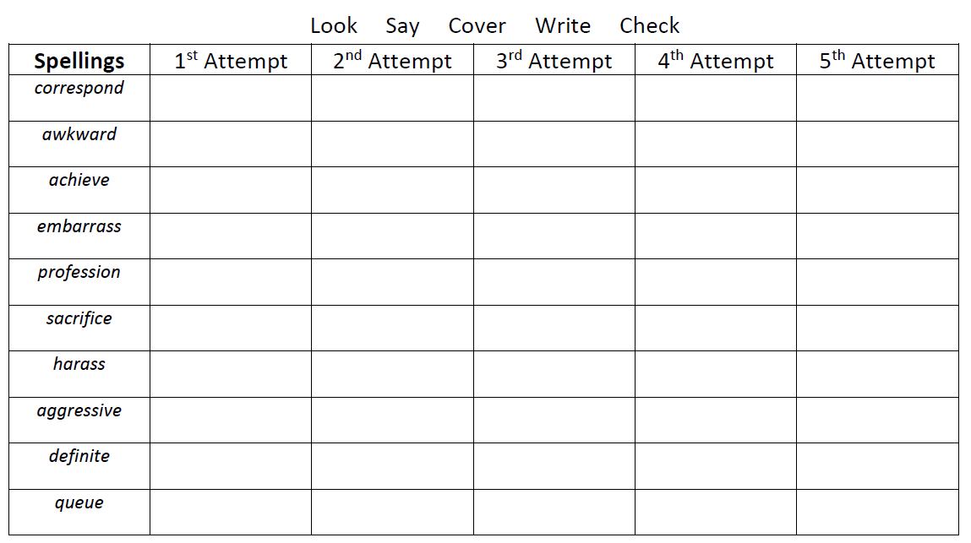
Topic words: celestial, equinox, meteorite, extra terrestrial

Mrs Bird’s Group
 | 1st Attempt | 2nd Attempt | 3rd Attempt | 4th Attempt | 5th Attempt
action
instruction
information
promotion
imitate
ventilate
illustrate
separate
exaggerate

