Spellings – (Mrs Siddiqui’s group)
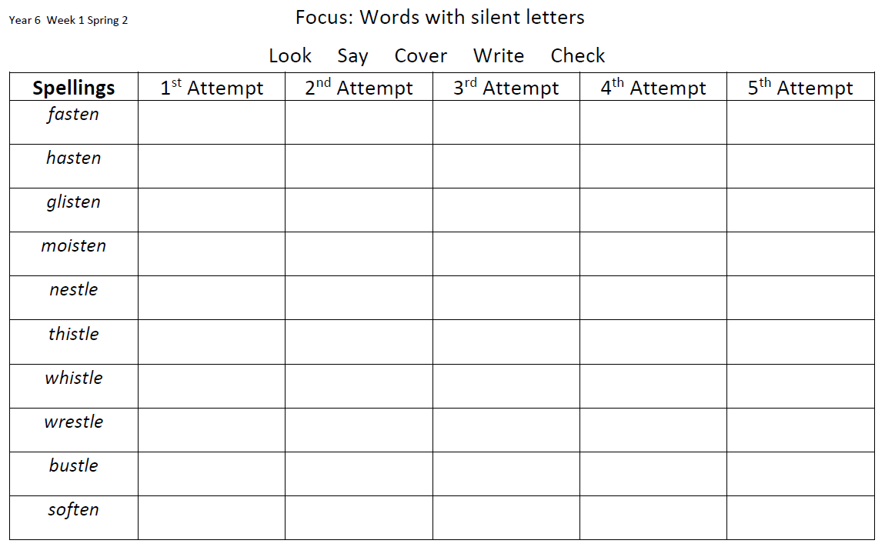

Mrs Bird’s Group
 | 1st Attempt | 2nd Attempt | 3rd Attempt | 4th Attempt | 5th Attempt
remember
consider
answer
quarter
thunder
quicker
better
sister
mother
brother

