Home Learning
English
This week we are reading ‘Oliver’s Vegetables.’ Please watch the video below if you need to recap the story: https://www.youtube.com/watch?v=jpzGIY_RSUw

Today we are going to be writing a description of Oliver using the 5 Ws.
These stand for:
Why?
When?
Where?
What?
Who?

Please choose one of the star choices below and complete the activity:
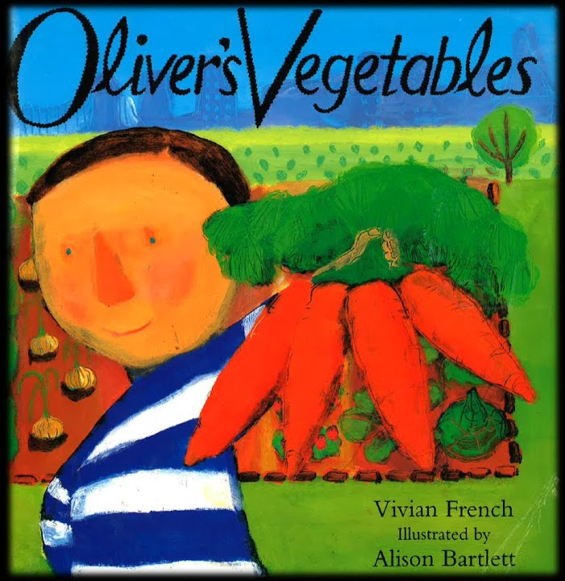
Please look at the picture below and use it to finish the sentences.

Oliver is wearing a__________________________________ shirt.
His eyes are ______________ and his hair is ______________
He likes to eat __________________.
Oliver is going to ______________________________ house.
He feels __________________ when he finds the ____________ carrot.
Please look at the picture below and use it to answer the 5 Ws in full sentences.

Who is in the picture?
What does he look like?
Where is he going?
When did he go to his Grandpa’s house?
Why did he go to his Grandpa’s house?

______________________________________________________________________________________________________________________________________________________________________________________________________________________________________________________________________________________________________________________________________________________________________________________________________________________________________________________________________________________________________________________________
Please look at the picture below and use it to answer the 5 Ws in full sentences.
Challenge: Try and add in more information to each answer using the story.

Who is in the picture?
What does he look like?
Where is he going?
When did he go to his Grandpa’s house?
Why did he go to his Grandpa’s house?

______________________________________________________________________________________________________________________________________________________________________________________________________________________________________________________________________________________________________________________________________________________________________________________________________________________________________________________________________________________________________________________________

