Home Learning
English
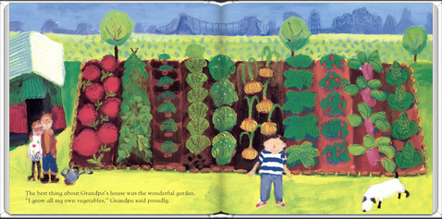
Today we are going to be focusing on the vegetable garden in ‘Oliver’s Vegetables.’

Below, I have put some pictures of all the different vegetables that Oliver’s grandpa has in his garden. We are going to be playing ‘Guess the Vegetable.
To play:
- Pick a vegetable and keep it a secret.
- Write a description of that vegetable.
- Ask a family member or classmate to guess what vegetable you are describing.

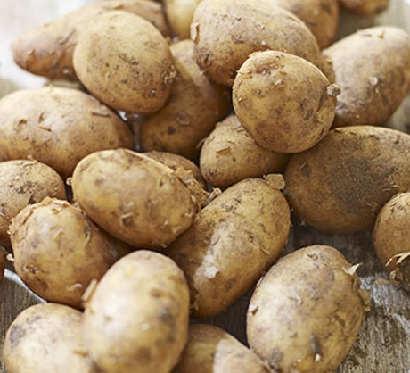
Vegetable Pictures:
Potatoes
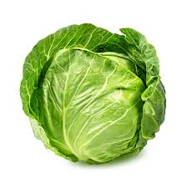
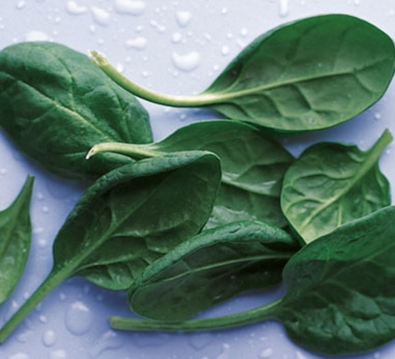
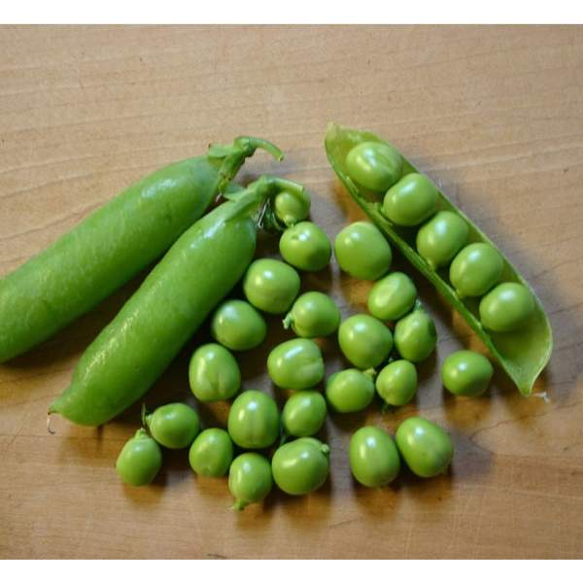
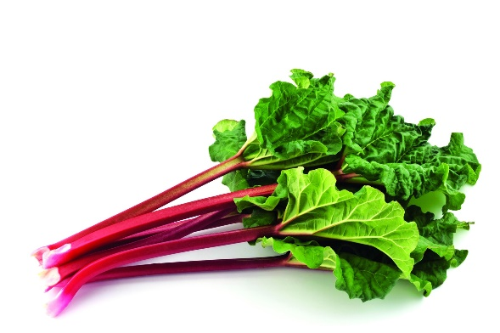
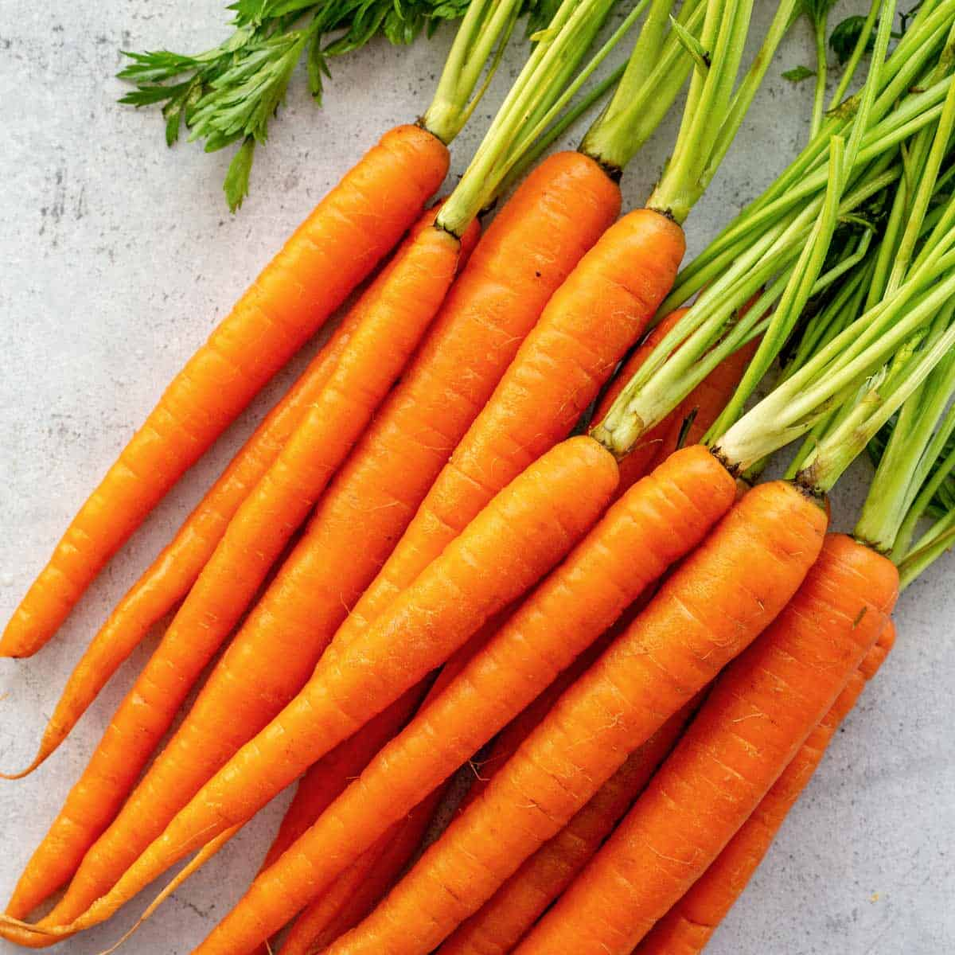
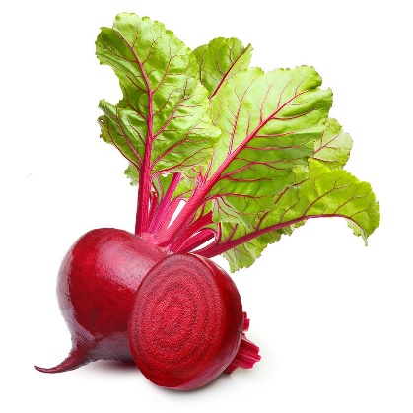
Peas
Rhubarb
Spinach
Cabbage
Beetroot
Carrots

Please choose from the star choices below and complete the activity:

Please choose a vegetable above and think about what it looks like. Then write a sentence describing what it looks like and see if your friends or family can guess.

Please choose a vegetable above and think about what it looks like. Then write three sentences describing what it looks like and see if your friends or family can guess.

Please choose 2 vegetables above that are similar and have a go at writing a paragraph to describe each one.
Really focus on your description. Then you can show it to your friends or family to see if they can guess.

