Friday 12th March 2021
Squirrels Homework
English
This week we have been reading the story of ‘Oliver’s Vegetables.’ Please have a go at retelling the story to your parents.
Then I would like you to find some vegetables in your own fridge. We have written some sentences focusing on sight, hearing and touch but now I would like you to have a go at writing some sentences about what they taste like.
Can your parents have a go at describing what they can touch, see and hear about the vegetables you have chosen.

Year 1 – Please write 5 sentences using the stem sentence below to help you.
I can taste …
Challenge – Have a go at adding in an adjective in each of your sentences.

Year 2 – Please write a paragraph about what your vegetables taste like including adjectives.
Challenge – Have a go at adding in expanded noun phrases into your writing.

Maths:
This week the children have been learning about how to measure weight using non-standard units.
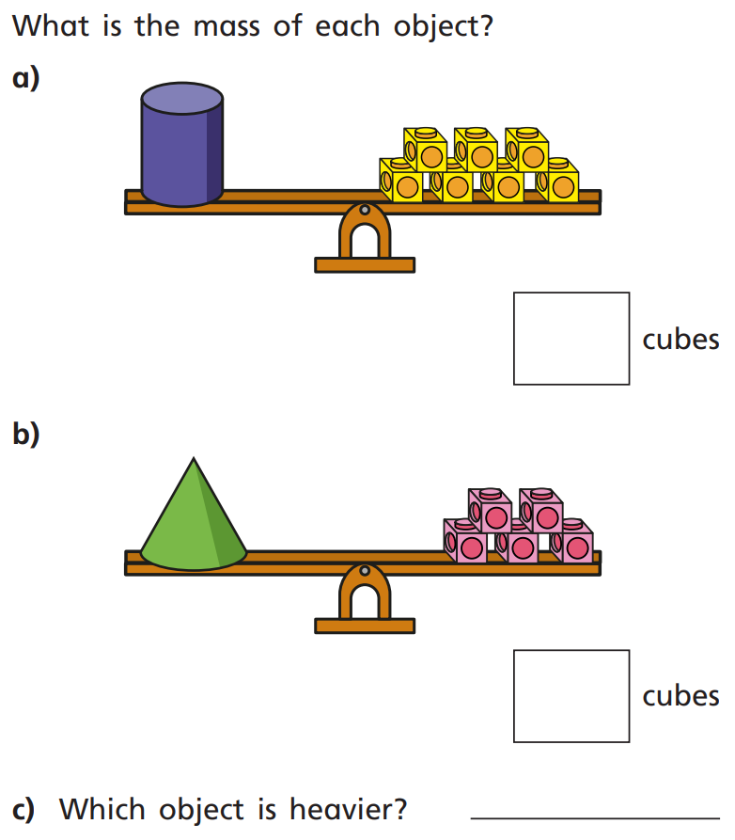
1.

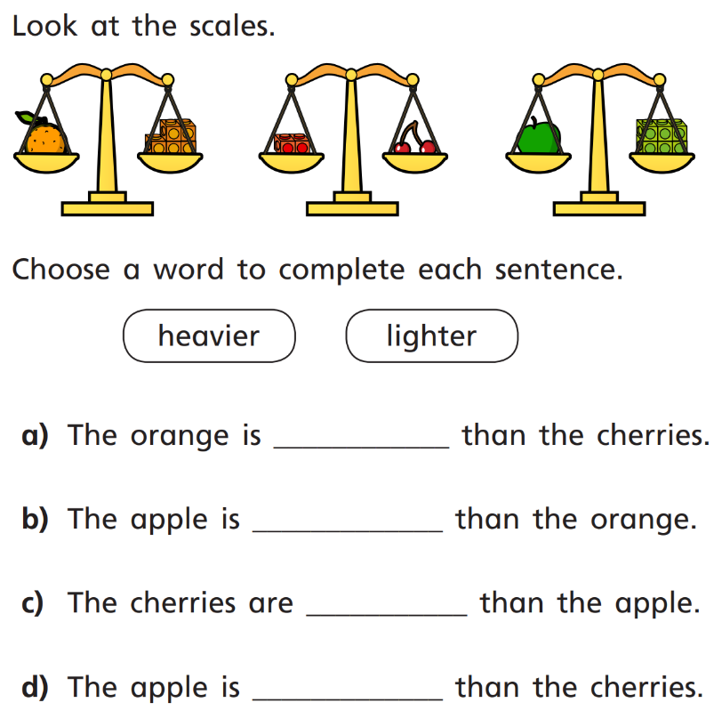
2.

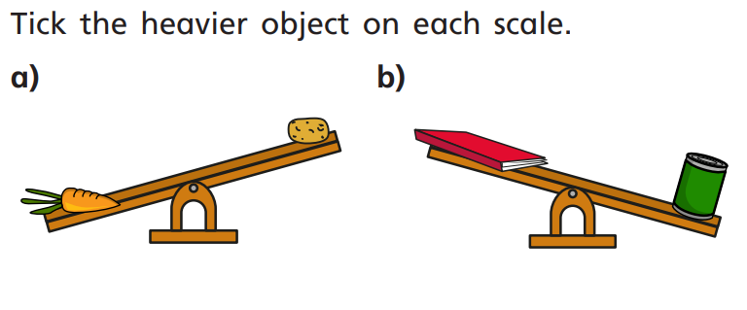
3.

Challenges:
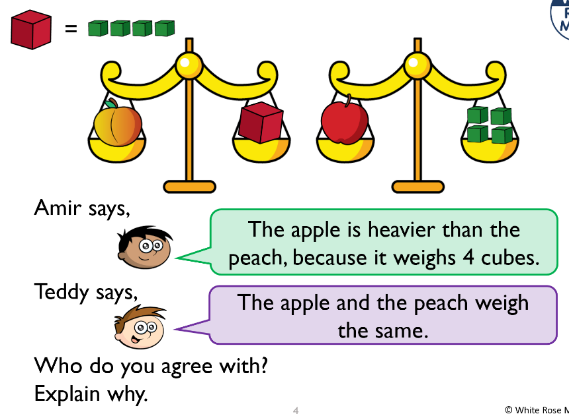
1.

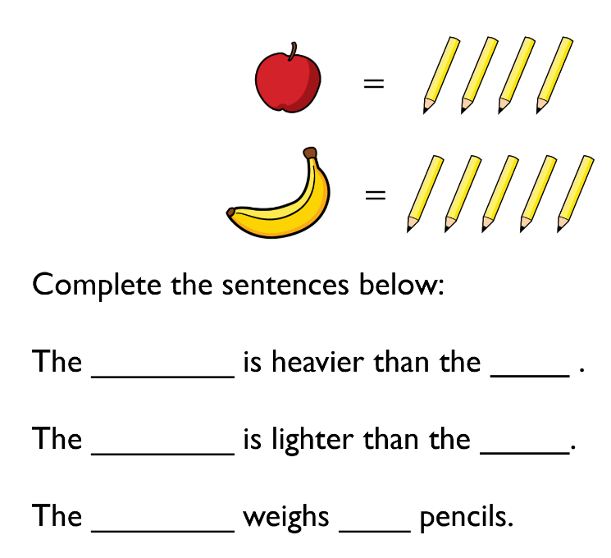
2.

