Squirrels Home Work – 26.03.2021
Maths
This week, both year 1 and 2 have been learning about ‘Position and Direction.’
Please have a look at the questions below and have a go at answering them.

Questions:
1. Please draw what the shapes will look like after each turn:

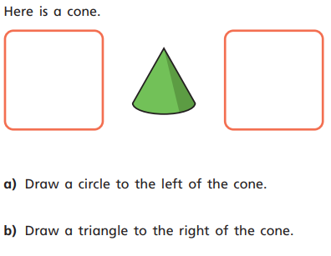
2.

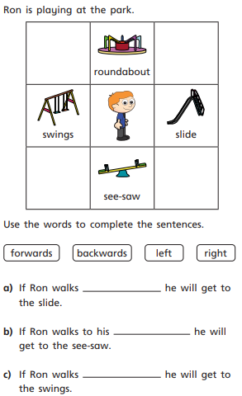
3.

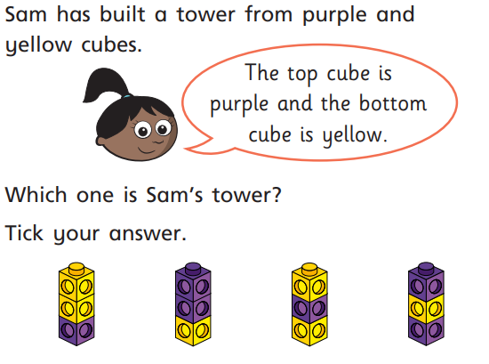
4.

English
This week, we started the story ‘Camille and the Sunflowers.’
Please watch the link below to recap the story: https://www.youtube.com/watch?v=3WD6n97L6G0

At the end of the story, Vincent is asked to leave Camille’s town. Next week, the children are going to be writing a letter to Vincent as Camille. Please complete the activity below to help you with your ideas for next week.

Year 1:
Talk to your adult about what you (Camille) thinks about Vincent. Use the story to help you give reasons. Then have a go at writing 4 sentences about what Camille thinks of Vincent.

Year 2:
Talk to your adult about what you (Camille) thinks about Vincent. Use the story to help you give reasons. Then have a go at writing a paragraph about what Camille thinks of Vincent giving reasons for your answers.

