Home Learning
Maths
Year 1:
Today we are going to be ‘Adding lengths.’
Please watch this video: https://vimeo.com/511039862

Activity:
1. A short piece of train track is 5 cubes long.

A long piece of train track is 9 cubes long.

- What is the total length of a short and a long piece together? ________ cm

- What is the total length of two short pieces? __________ cm

2. Mo uses paper clips to measure the length of some objects.
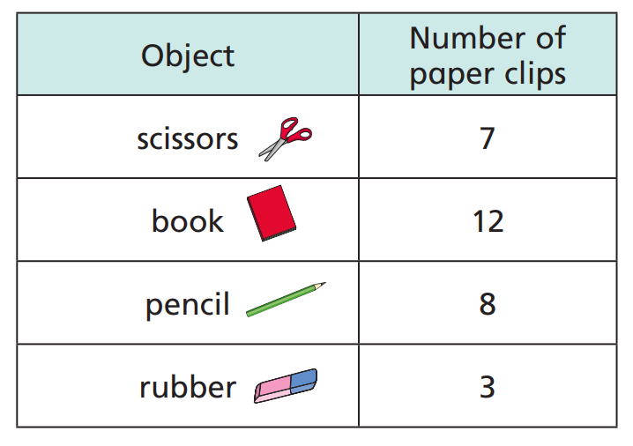

- What is the total length of the scissors and the book?

____________ paperclips

- What is the total length of the pencil and the rubber?

____________ paperclips

- Which two objects measure 10 paperclips in total?

___________ and ____________

- Which two objects measure 15 paperclips in total?

___________ and ____________

- Is there more than one answer?

3. Practical
Please go and find yourself 5 objects. Please choose a non-standard unit to work out how long each one is. Some options are:

- Cubes
- Paperclips
- Hands
- Pens
- Sweets
- Shoes
- Lollipop Sticks

Fill in the table below and have a go at answering the questions below:
Object: | Length:

- Which two objects added together make the biggest length?

___________ and ____________

- Which two objects added together make the smallest length?

___________ and ____________

Challenge:
Eva, Dexter and Rosie are comparing the ribbons they have.
Unfortunately, Dexter has lost his ribbon.
My ribbon is shorter than Rosie’s, but longer than Eva’s.
He says,

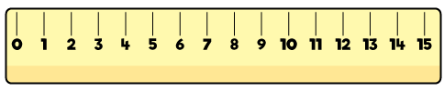
Dexter
Rosie
Eva

How long could Dexter’s ribbon be?

Year 2:
Today we are going to be learning how to ‘Problem solve using length.’
There are some hint boxes on each question to help you answer them.

Activity:
1. Annie has a piece of ribbon 80 cm long.
Hint: Think about how many tens you need to get from 50 to 80.

She cuts the ribbon into 2 pieces.

The longer piece is 50cm long.
How long is the shorter piece? ____________ cm

2. Kim measures the length of 2 blocks.

How much longer is brick A than brick B? ________________ cm

3. Here are four shaded bars:

Put the bars in order of length from shortest to longest.
_________________________________________________________________

4. The tree is 18 m shorter than the building.

Hint: Work out how tall the building is by adding 24 and 18 together.

What is the total height of the tree and the building?
_________________ m

5. Ron has 20 cubes.
Hint: Share the cubes into 5 groups and work out how many is in each tower and then find out the height.

He uses all the cubes to make 5 equal towers.
Each cube is 3 cm tall. How tall is each tower? _______________ cm
Challenges:
1. A teddy sits on top of two cubes.
Each cube is the same height.
The teddy is 12 cm tall.
How tall is each cube? _________ cm

2. Two strips of paper are put side by side.

Do you agree with Rosie? Explain.

3 Here are 2 pieces of ribbon.

The total length is 1 m.
One piece is 38 cm.
How long is the other piece? ______________ cm

