Home Learning
Maths
Year 1:
Today we are going to be learning about ‘Subtracting length.’
Please watch this video: https://vimeo.com/511040266

Activity:

1. A piece of string is 8 cubes long.

The string is cut into two pieces.
The short piece is 3 cubes long.

How long is the long piece? ____________

2. Sam takes 17 steps forwards.
She then walks 5 steps backwards.
How many steps is she way from the start? _______________

3. A teddy bear is 10 cubes tall.

A doll is 16 cubes tall.

How much taller is the doll than the teddy bear? __________________

Challenge:
A toy train is 18 cubes long.
A toy truck is 14 cubes long.
- How much shorter is the truck than the train?

- A toy car is 9 cubes shorter than the truck.

Draw the car:

Year 2:
Today we are going to be doing a recap of all our learning of ‘Length and Measurement.’
1.

2.

3.

4.

5.

6.
If you are not printing this work off, you can also do this using a ruler on plain paper.

7.
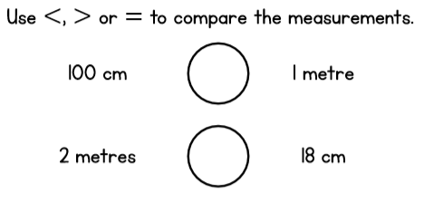

8.

9.

