Home Learning
Maths
Year 1
Today we are going to be learning about how to use a ‘ruler.’
Please watch this video to get started: https://vimeo.com/510394004

Activity:
1. How long is each object?
a)

The pencil is _________ cm long.

b)

The crayon is ____________ cm long.

c)

The brick is ____________ cm long.

Challenge:
Have a go at measuring 2 other objects, either in your house or at home.

2.
a) How long is the blue ribbon?

The blue ribbon is ___________ cm.

b) How long is the red ribbon?

The red ribbon is ____________ cm.

c) Which ribbon is longer?
The ____________ ribbon is longer.

Challenge:
How much longer is the ribbon?

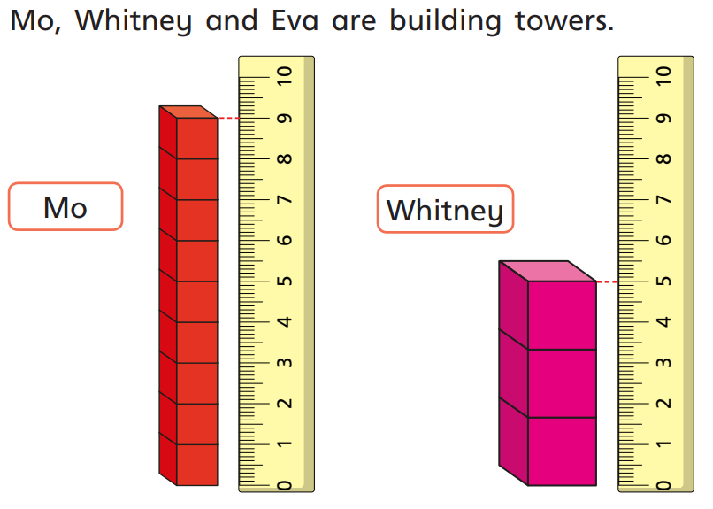
3. Mo, Whitney and Eva are building towers.

- How tall is Mo’s tower?
Mo’s tower is __________ cm tall.

- How tall is Whitney’s tower?
Whitney’s tower is _________ cm tall.

- How long could Eva’s tower be?
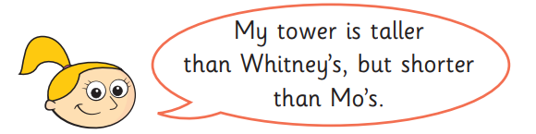

Eva’s tower is _____________ cm.

Challenge:
Is there more than one answer?

Year 2:
Today we are going to be learning about ‘Ordering lengths.’
There is no video for this lesson. Please have a go at the activities below.

Activity:
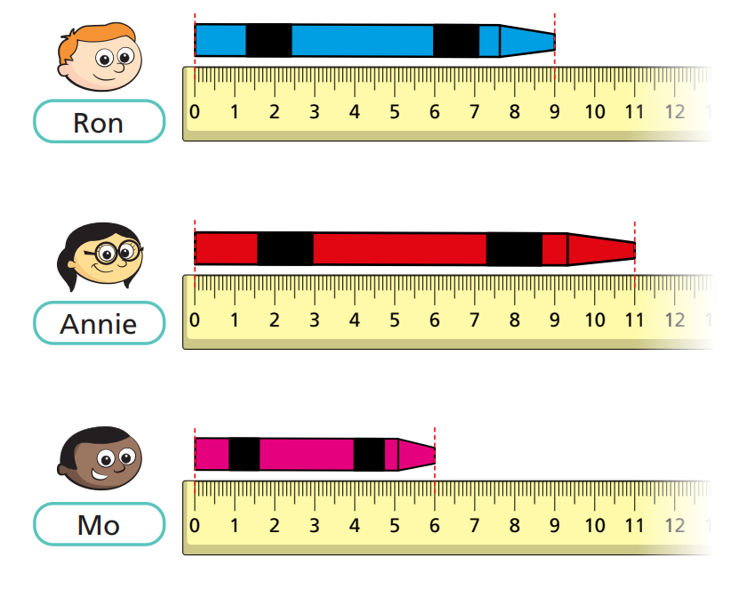
1. Roy, Annie and Mo each have a crayon. They are measuring the length of their crayons.

- Who has the shortest crayon? _____________

- Who has the longest crayon? ____________

Challenge:
How much longer is the longest crayon compared to the shortest crayon?

2. Ron compares the length of his crayon with Dora and Whitney’s crayons.
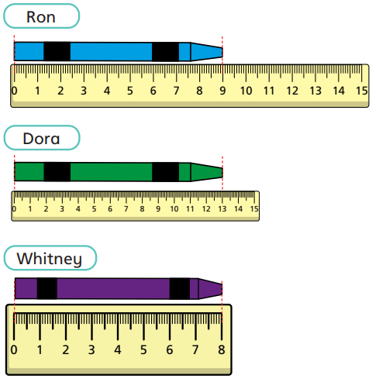

- How long is Dora’s crayon? ______ cm

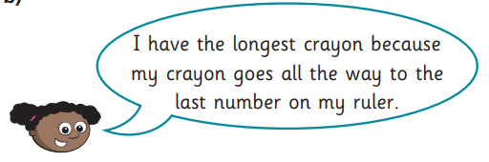

Why is Whitney wrong? ___________________________________
_______________________________________________________

3. Choose 5 objects from home or in the classroom.
a) How could you estimate which will be the longest? _______________
_______________________________________________________

b) Use a ruler to measure the length of the objects to the nearest centimetre and complete the table below.

Object: | Length:
 | cm
 | cm
 | cm
 | cm
 | cm

- Write your objects in order of length. Start with the shortest object.
Shortest

_________________________
_________________________
_________________________
_________________________
Longest
_________________________
Challenges:
1. There are 4 buildings.
- Building A is 22 m tall.
- Building B is half the height of building A.
- Building C is 14 m tall.
- Building D is double the height of building C.
Put the buildings in order from the tallest to the shortest.
Draw a picture to help:

Can you put them in order?
Longest

Building _______________
Building _______________
Building _______________
Building _______________
Shortest

2. Three children measure the same toy car.
Eva says that the car is 6 cm and 5 mm.
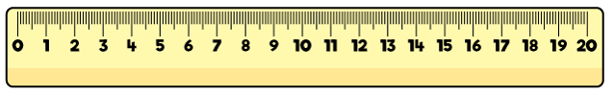

Dexter says that the car is 5 cm.

Annie says that the car is 4 cm and 5 mm.

- Who is correct? ________________
- Who is incorrect? ________________
- Explain your answers: __________________________________
__________________________________________________

Longer than a metre: | Shorter than a metre:
3. Sort the lengths into a table.
54 cm
98 cm
140 m
16 cm
1m 20 cm
110 cm

