Home Learning
Religious Education
Last week we learnt about what is precious to Jewish people. Today we are going to be learning about:
“LQ: What does a mezuzah remind Jewish people about?”

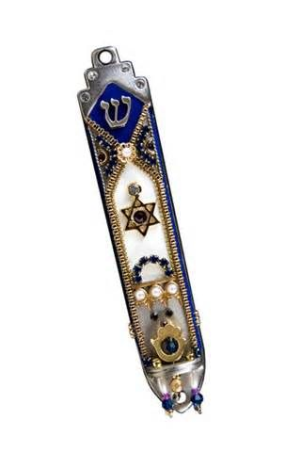
Can you remember what a Mezuzah is? Have a look at the pictures below and think about what questions you would like to ask about it:
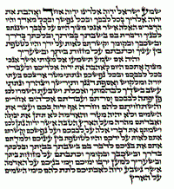

Let’s remind ourselves. Please watch this video that explains what a Mezuzah is: https://www.youtube.com/watch?v=72QaHckhjIw

Now let’s look a little deeper. Inside a Mezuzah is a scroll which has a prayer called a ‘Shema’ that is very important to Jewish people. Please look at the prayer below and answer the questions below with your thoughts.
What do you notice?
Is there anything you would like to know?

The first line of the ‘Shema’ means:
“Hear O Israel, the Lord is our God, the lord is one.”
What do you think this means to Jewish people? Please write your thoughts below using the sentence starter:

I think that this means _____________________________________
_______________________________________________________
_______________________________________________________

Let’s listen to the Shema: https://www.youtube.com/watch?v=NCuySHhmh-A

Activity 2:
The first line of the Shema tells Jewish people to pay attention to their belief in one God.

What is your belief? Please draw a picture below of something you believe in and write a sentence explaining why:

_______________________________________________________
_______________________________________________________
_______________________________________________________
_______________________________________________________

Activity 3:
The Mezuzah is placed outside the door of a Jewish household because they are told to by the ‘Shema.’ They then remember the important words of the Shema as they go past it.

Which words would you like to have displayed every single day to remember?
Write some words down with your adult or in class and decorate some words to stick up on your door as a ‘Mezuzah.’

