Home Learning
Science
This term we are learning about plants. Last week we were plant investigators, and we had a look at what we could see outside. This week we are going to be detectives!

Activity 1:
Please look at the pictures below. Now it is your turn to go outside into the garden or for a walk and see how many of these plants you can see.

Flower: | Number:
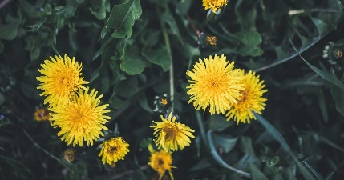
Dandelion
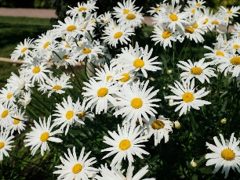
Daisy
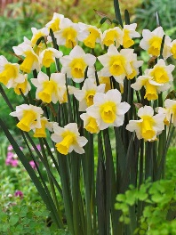
Daffodil
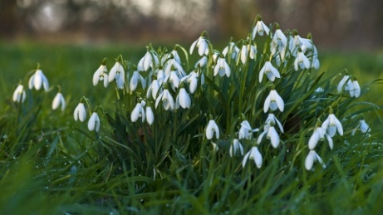
Snowdrop
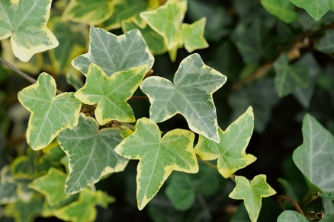
Ivy
Activity 2:
Have a look at the diagram of the flower below and label the empty box.
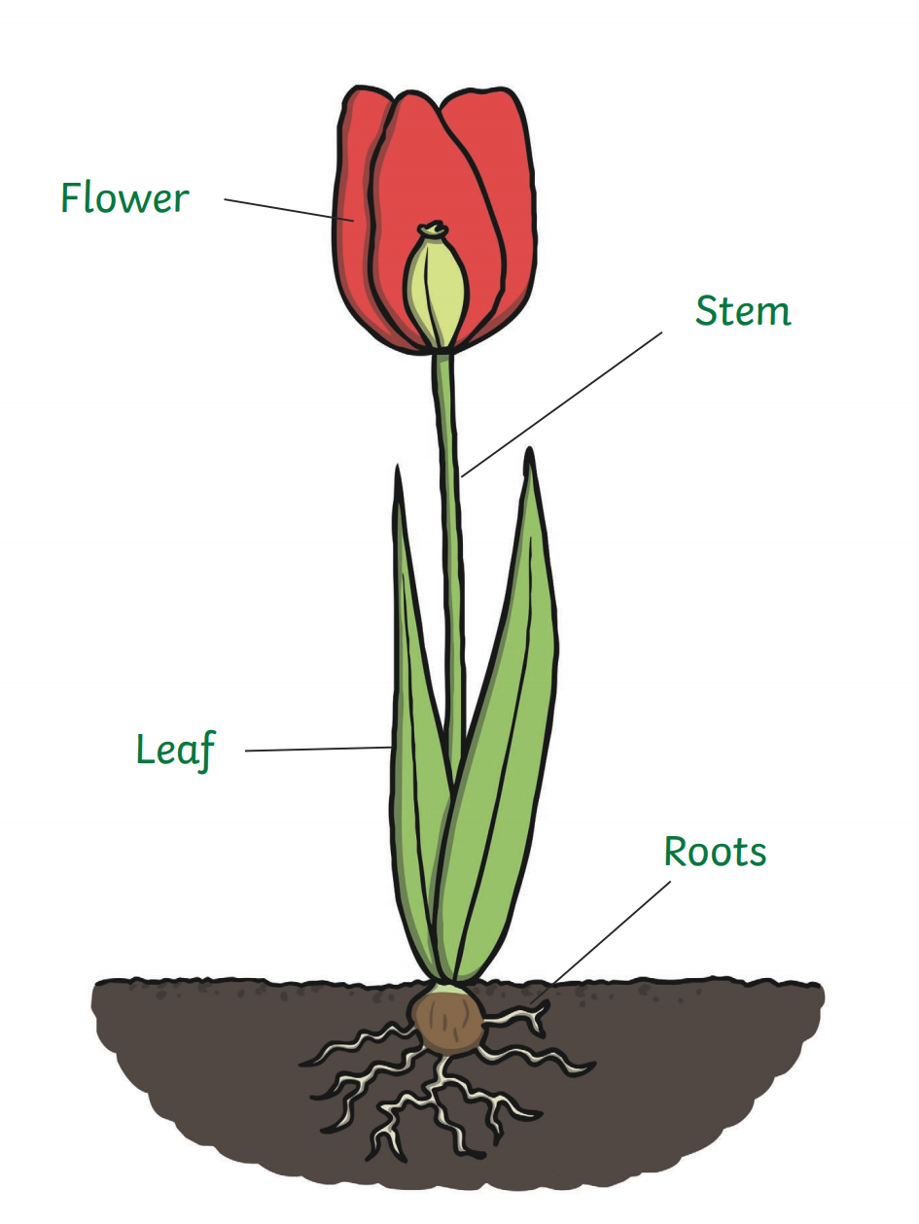

Challenge: Can you label the ‘Shoot?’

We are going to be focusing on roots today, so let’s go and find a weed so we can take a look at the roots.
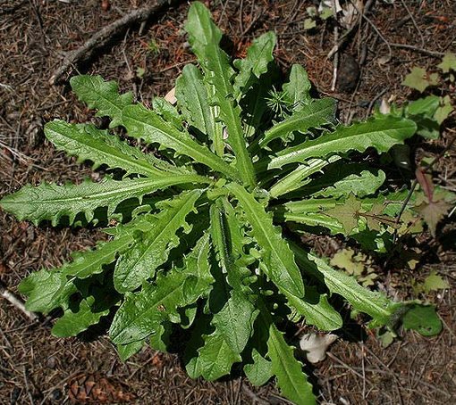
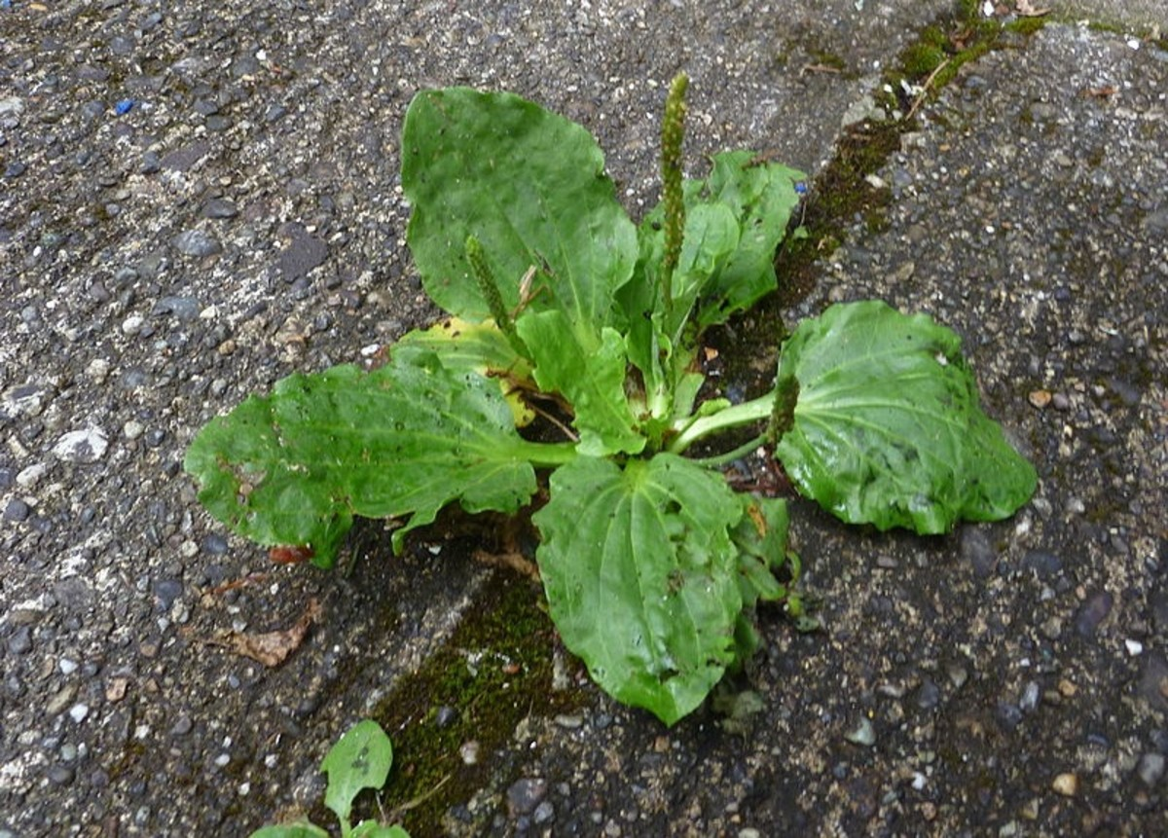
Here are some common weeds you may find:

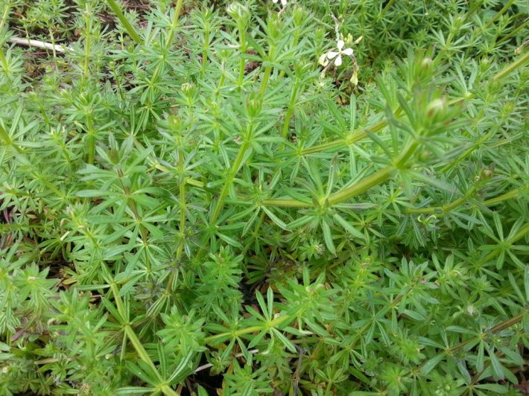

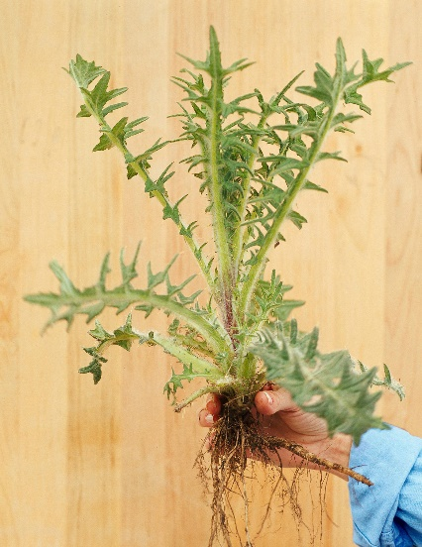
When you pick the weed, make sure you push your hand right to the bottom of the plant and pull gently. You should have something like this:

What do you notice?

Let’s draw:
Please go outside and look at a tree. What do you think the roots would look like on the tree? Would they be different than a smaller plant?

Draw your thoughts in the box below:

Activity 3:
Practical – Using the weed that you have collected (or you can pick another one) follow the instructions below:

- Place the weed’s roots into a bowl of water.
- Carefully shake the roots in the water to get rid of the soil.
- Then place the clean roots into another bowl of clean water.
- Finally, watch to see what happens.

Please write your observations on the lines below:
________________________________________________________________________________________________________________________________________________________________________________________________________________________________________________________________________________________________________________________________________________________________________________________________________________________________________________________

