Home Learning
Topic
Our topic for this term is ‘My secret garden.’
We are going to be completing a few activities focusing on this topic.

Activity 1
As you may have noticed, we are moving into the season of Spring. Please watch this video to see what happens to nature as we go into Spring: https://www.youtube.com/watch?v=RcTATfqBsRo

Please draw some pictures to show Miss MacMillan what happens as we go into Spring below.

Activity 2:
We are going to be learning about hot and cold climates and how plants adapt to be able to live in those environments.
Let’s watch this video to learn more about what a climate is: https://www.bbc.co.uk/bitesize/topics/z849q6f/articles/z7dkhbk

Please look at the map below: Can you find these countries on the map?
Nigeria | Siberia | India | New Zealand

Find the countries on the World Map below and label them on the blank map underneath.
To answer this question, you can:
- Type the names into the boxes provided on the map.
- You can write them if you have printed the work.
- If you are unable to print or edit the document, please write down the numbers 1-4 and write the country that it points to.

Challenge:
Where are all the hot and dry climates on the map?
- The North Pole
- The Equator
- The South Pole

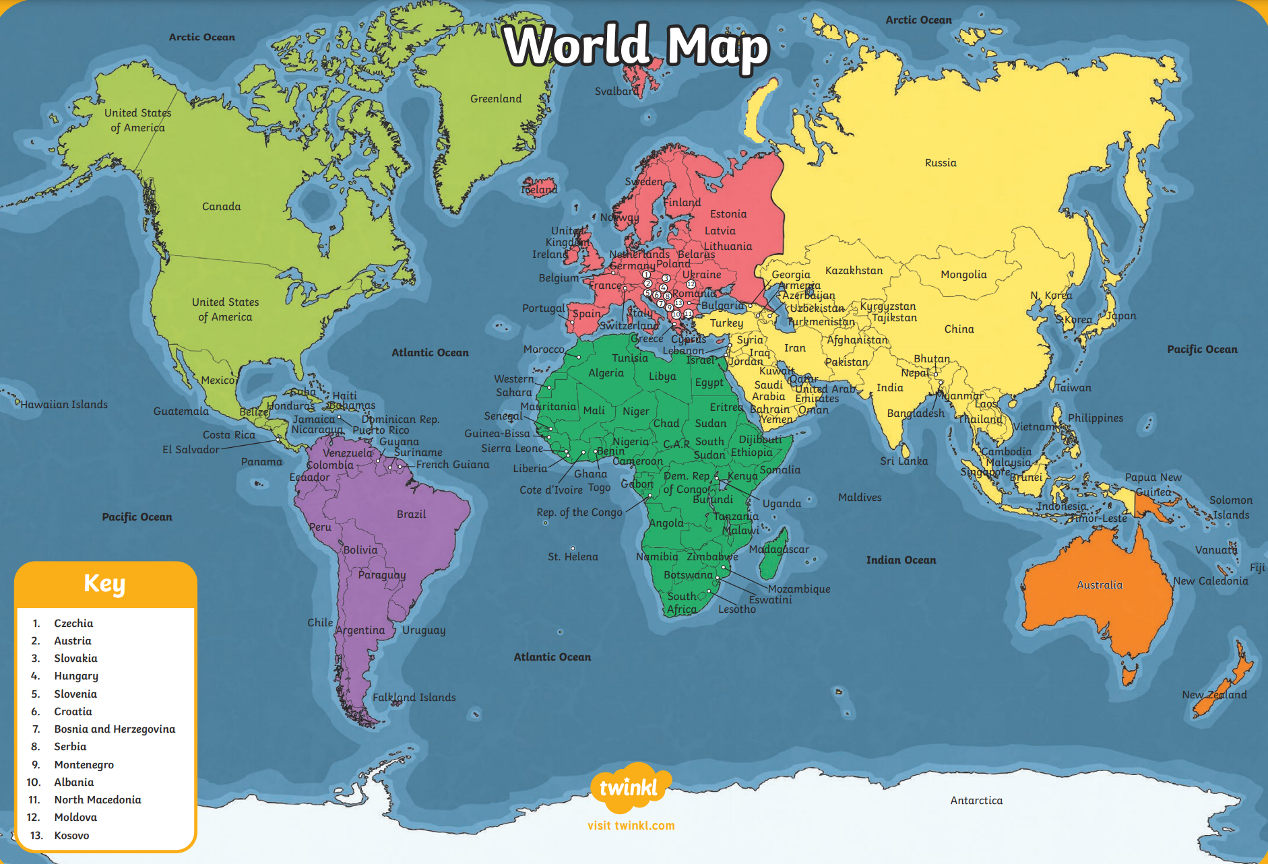

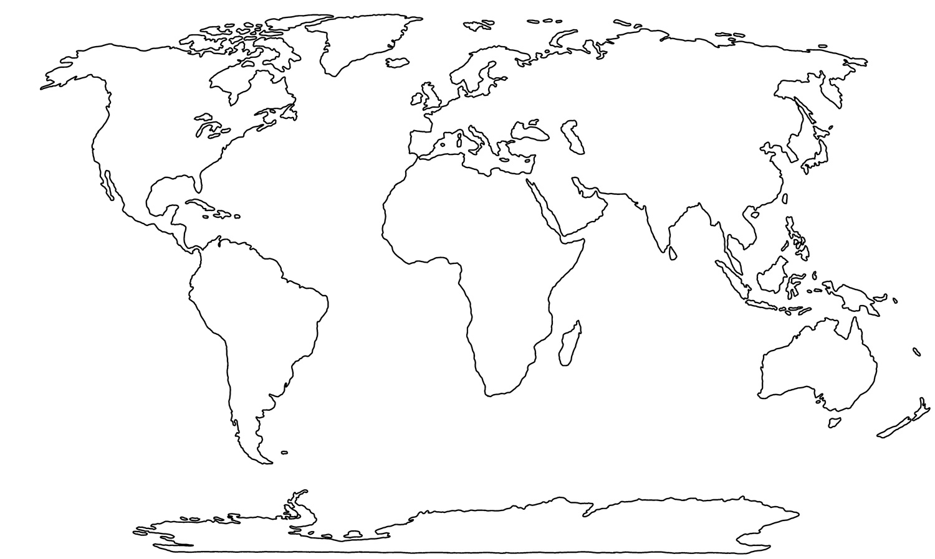
4.

3.

2.

1.

Equator
Activity 3:
We are going to be comparing plants in a hot and a cold climate.
Please watch this video to find out more: https://www.youtube.com/watch?v=lhR9vDAIyKI

Look at the pictures below. Please write a sentence about each one explaining what climate they grow in. There are stem sentences to help:
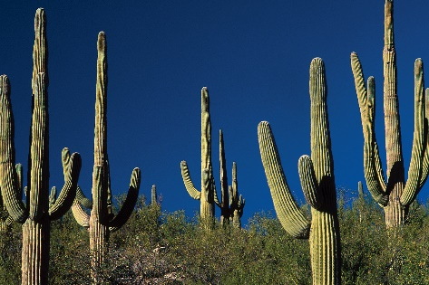
1. Cactus

A cactus lives in a _____________ climate because__________________
__________________________

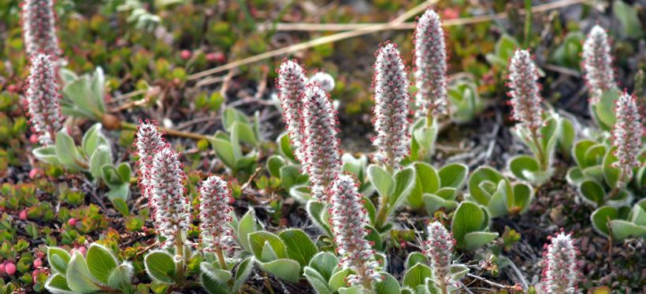
2. Arctic Willow:

An Arctic Willow lives in a _____________ climate because__________________
__________________________

