Home Learning – Monday 1st March 2021
Maths

Complete the warm up questions then answer 3 or more of the questions below. Choose from set A, B or C.

Warm Up

Today we are revising our place value knowledge.

1. Write thirty-four thousand, nine hundred and seventy-four in figures.
2.Write six hundred and two thousand and ninety in figures
3.Write 878,002 in words.
4. Write 301,999 in words.
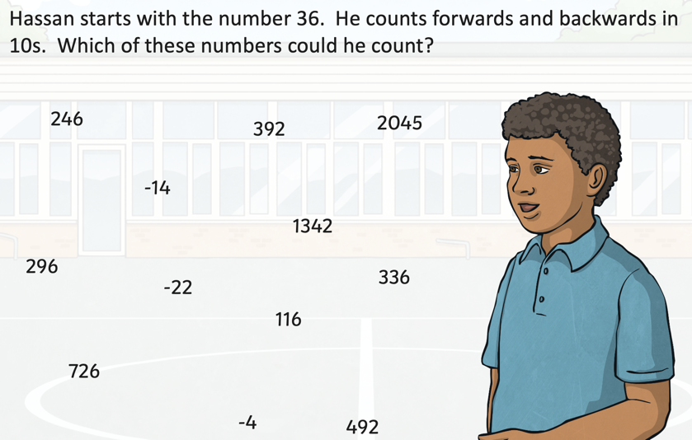
5.

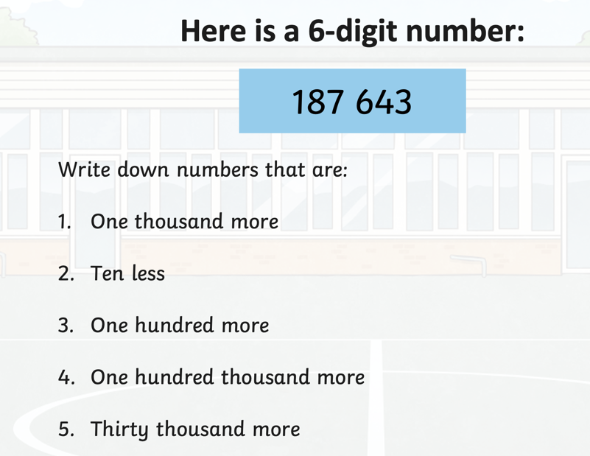
6.

SET A

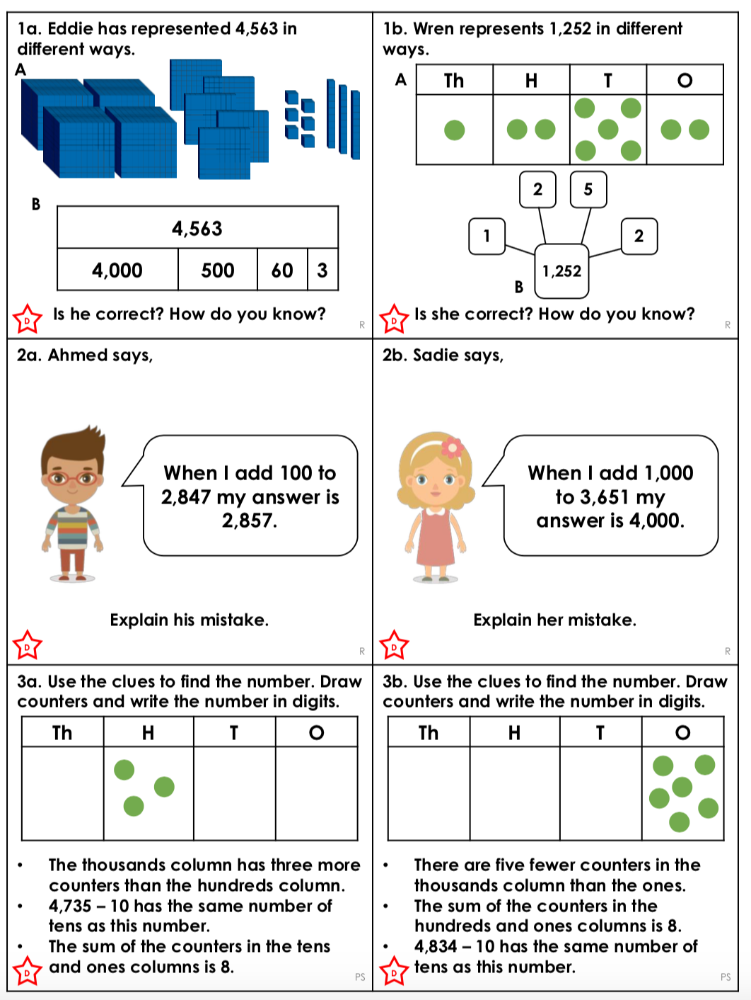

SET B

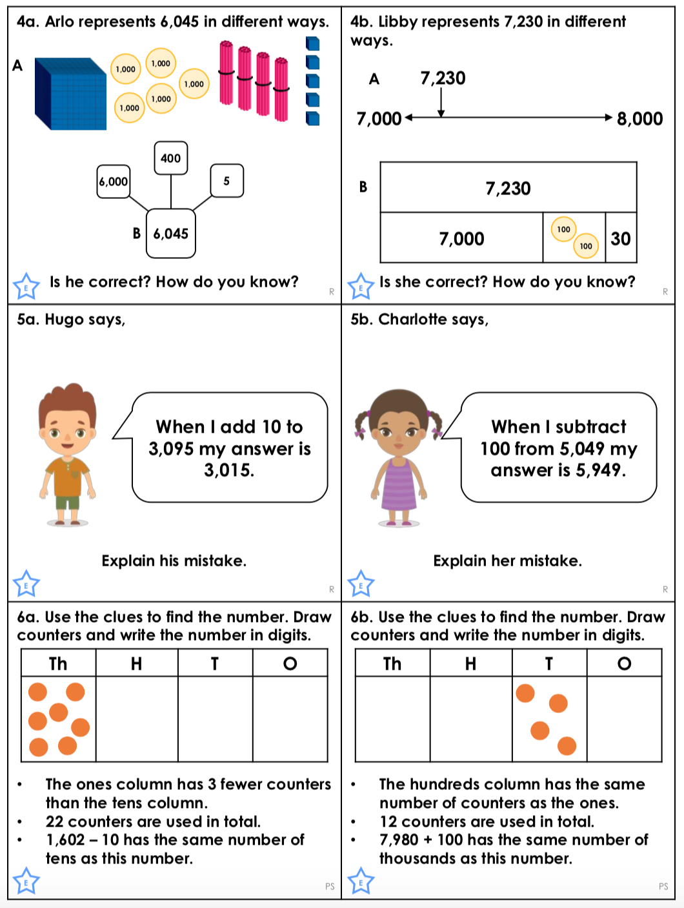

SET C

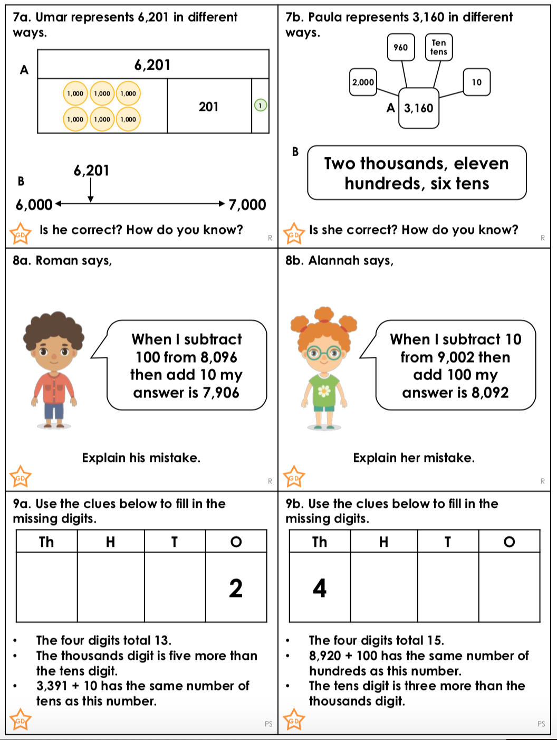

ANSWERS

SET A

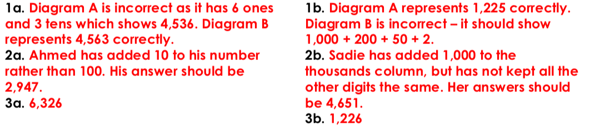

SET B

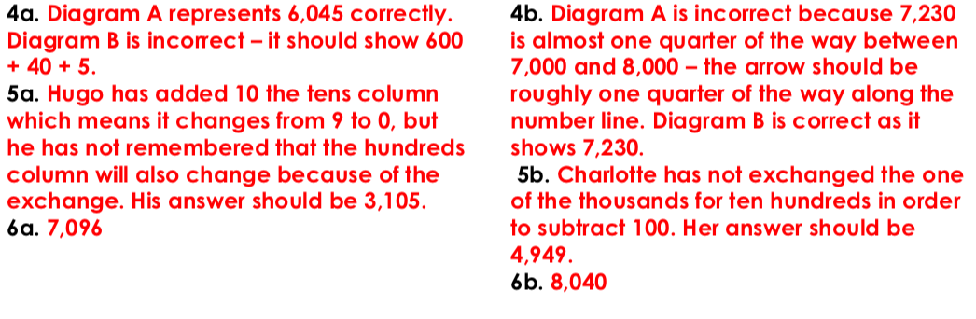

SET C

