Home Learning: Tuesday 2nd March 2021
Maths

Today we are going revise multiplying and dividing by 10, 100 and 1,000. Just remember the rule shown below. If you need to write the numbers in the correct place value columns then move the digits in to the correct place value column. Choose from A, B or C then complete the challenge questions if you are confident. 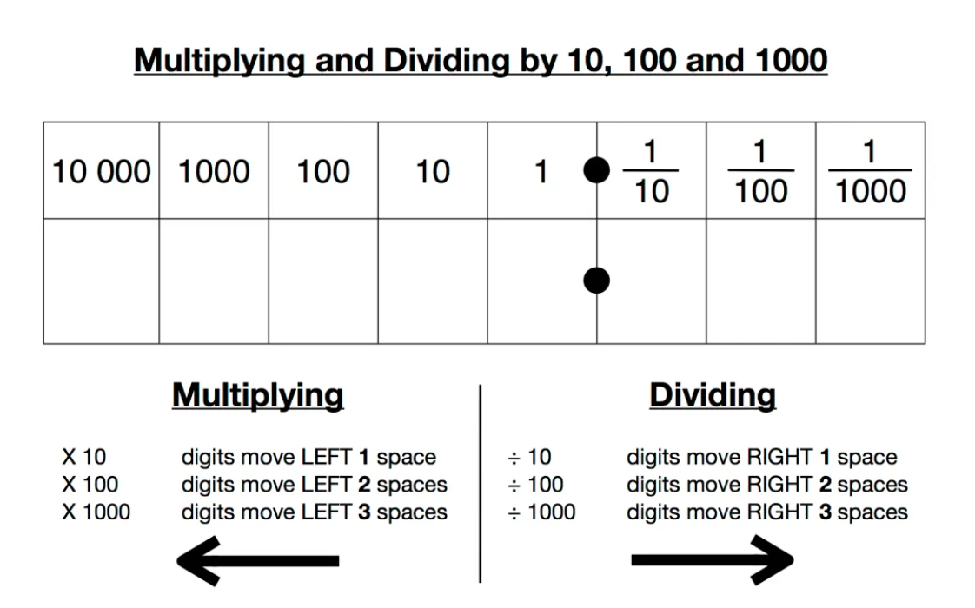

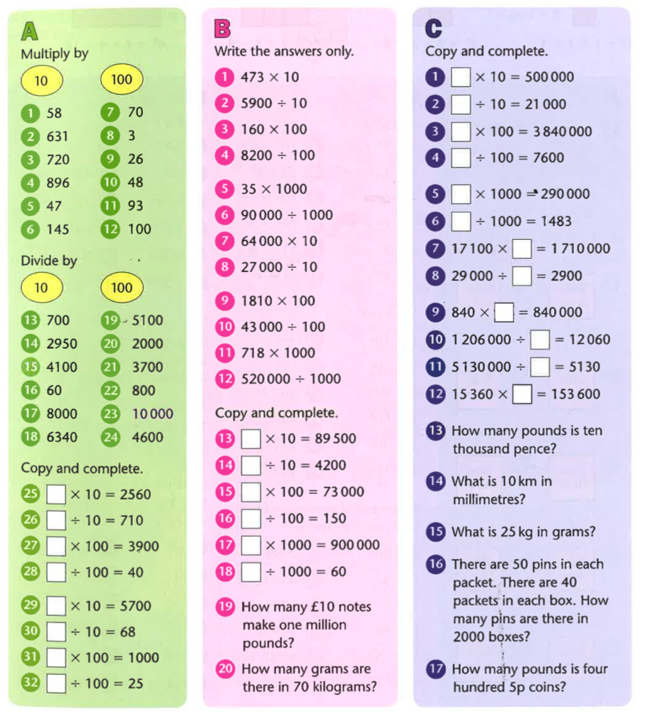

Challenge

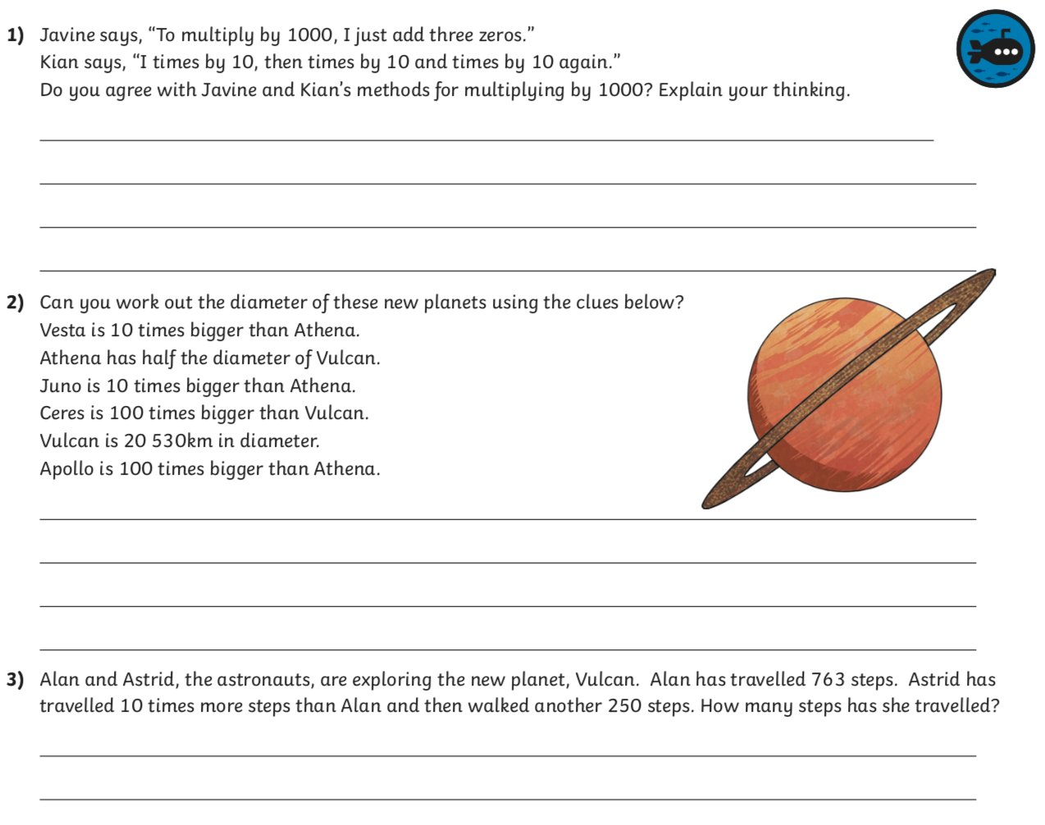

ANSWERS

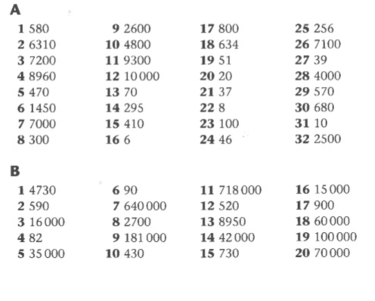
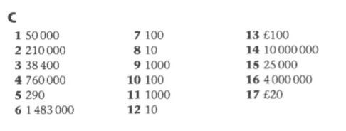

Challenge Answers

