Topic 2.3.21
Use an atlas or the internet to help you research the following:
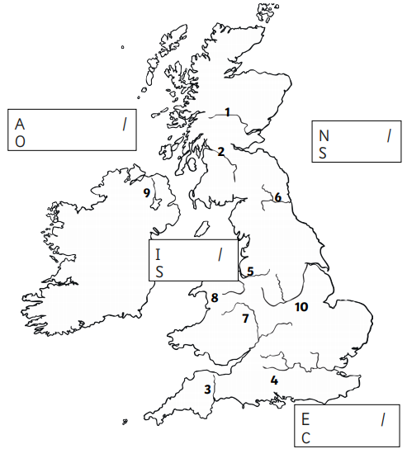

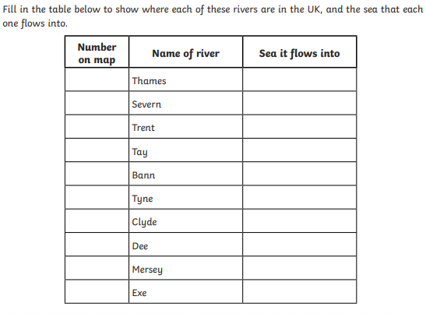

Challenge

