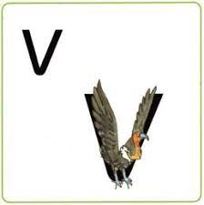
“V v vulture.”

___________________________________________________________
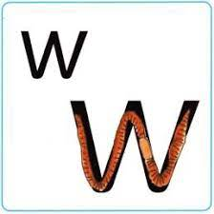
“W w worm.”

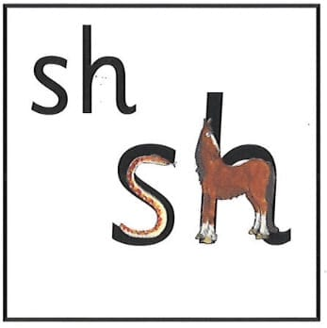
“Sh says the horse to the hissing snake.”

___________________________________________________________

