Home Learning 22.03.21

Maths

Choose either A, B or C then try the challenge!

A

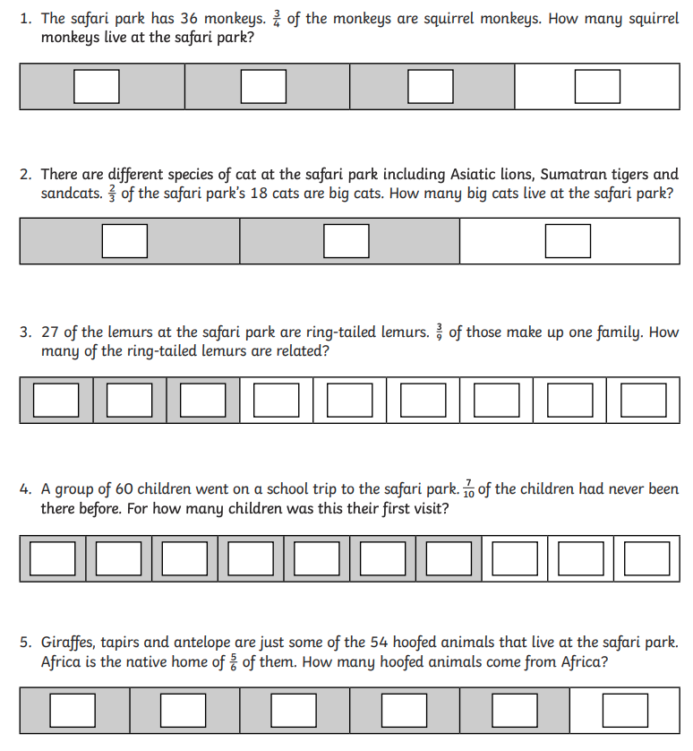

B

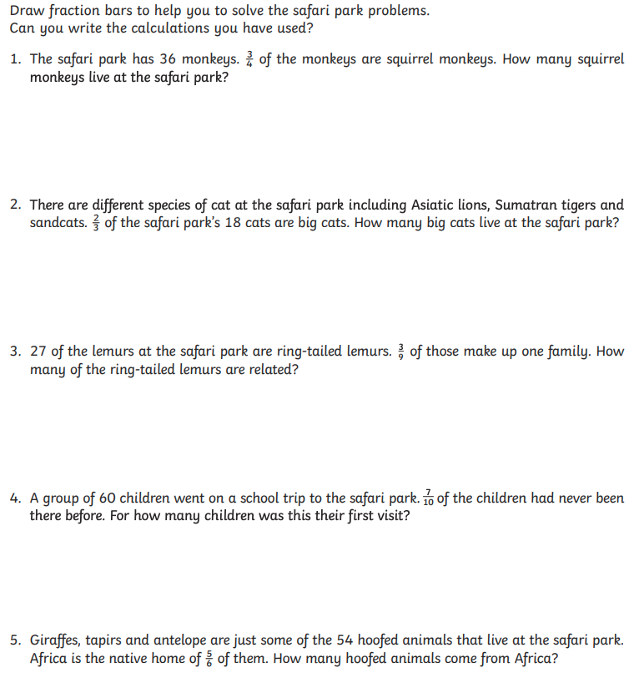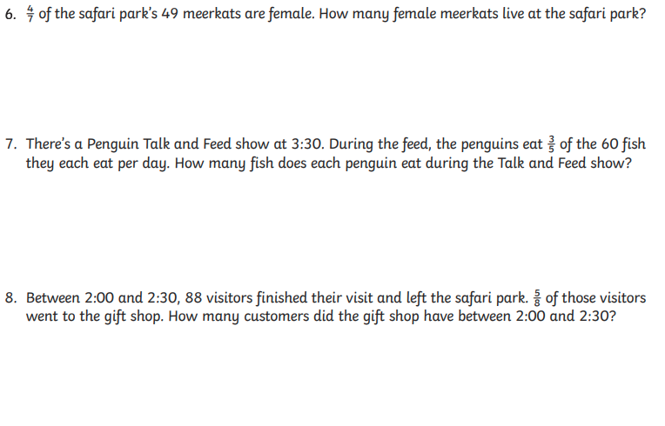

C

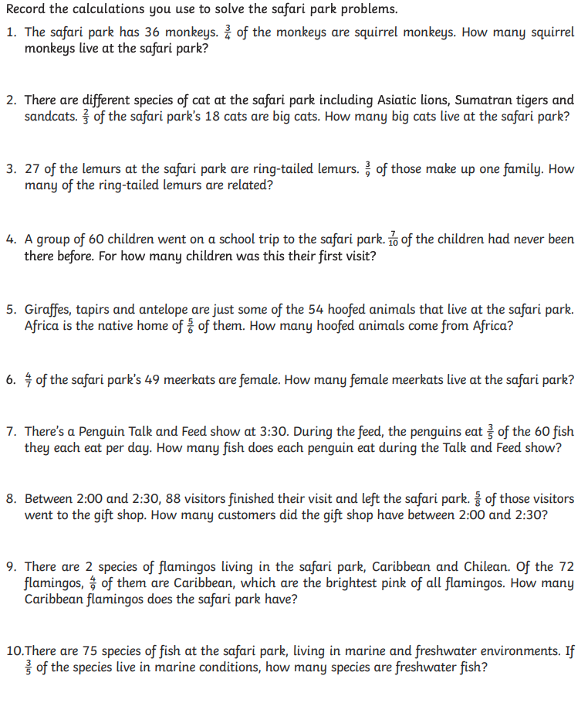

Maths Challenge

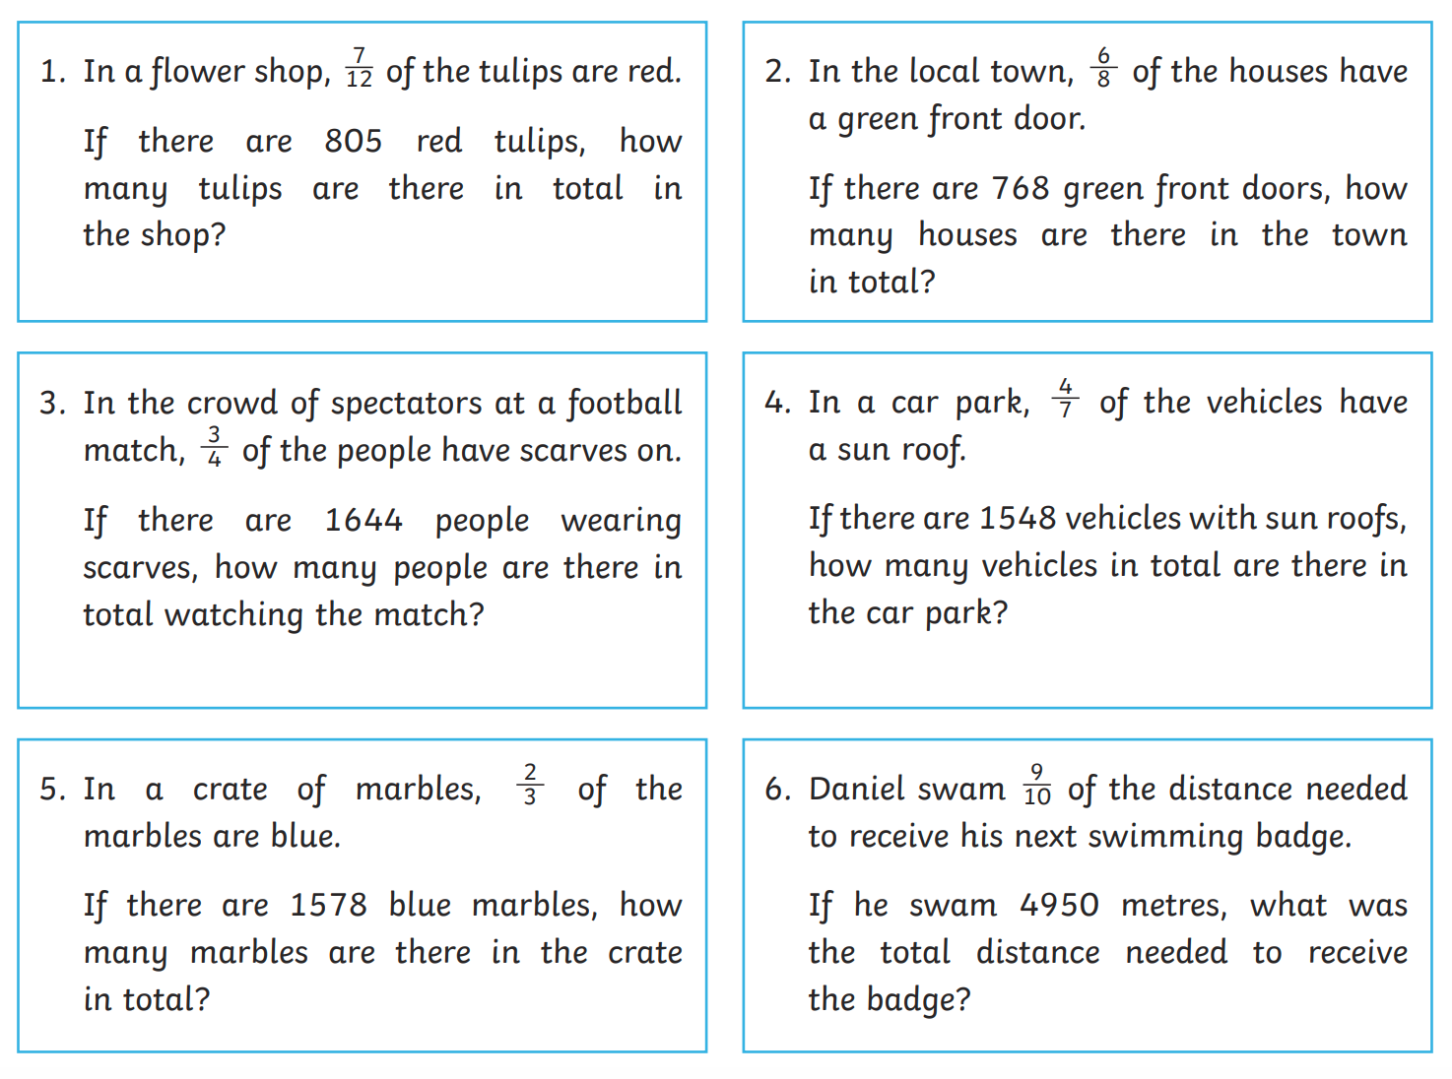

English

Improve these five sentences, by adding informtation using relative clauses:

1) Anna enjoyed toboganning.
2) Max did not like school work.
3) Mama was not looking forward to moving to Paris.
4) The journey was long.
5) The porter tricked them so they nearly missed their train.

Write 2 sentences for there, their and they’re.

Finally, read the piece of writing below and answer the questions below. These do not have to be contained in the boxes, you can write more.

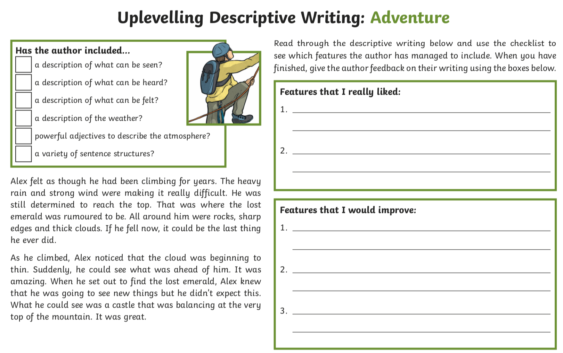

Don’t forget the spellings on Purple Mash.

