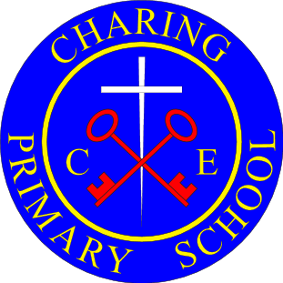
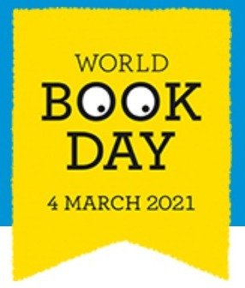
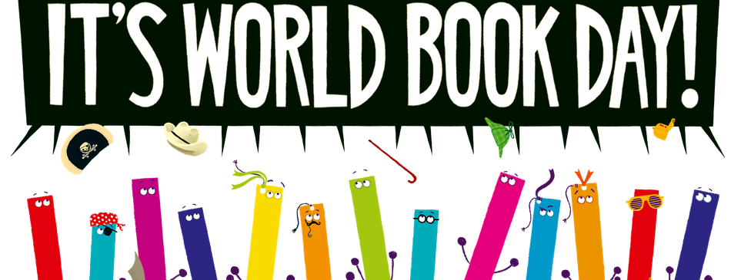
Thursday 4th March 2021

Do you have a favourite book or author?
Look on the school’s website on your home learning page to find out your teacher’s favourite book from when they were a child or what they are reading at the moment!

Today, make your own book.
It can be fiction, non-fiction, a graphic novel or a picture book (with or without words!), a poetry book or any other type of book, you decide!
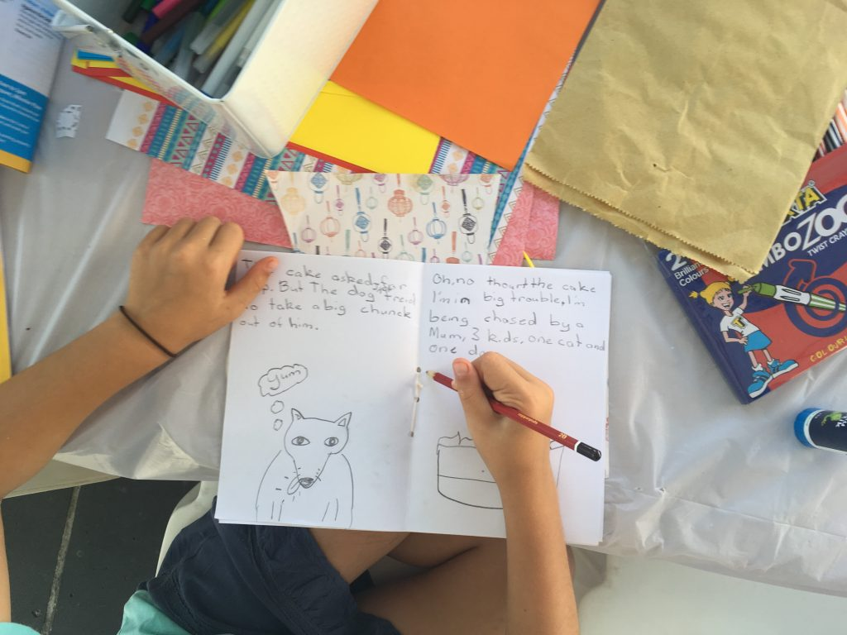
Here are some ideas:
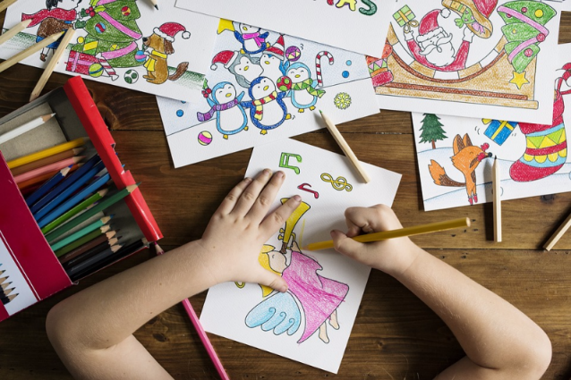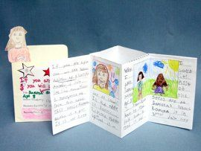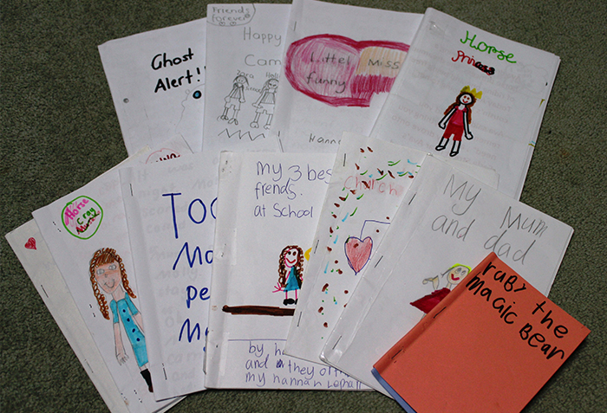
For ideas try…
https://home.oxfordowl.co.uk/kids-activities/creative-writing/
https://home.oxfordowl.co.uk/blog/4-tips-to-inspire-childrens-creative-writing/
Use the story generator pdf attached. There are also lots of other ideas to try using the link below.
https://www.worldbookday.com/resources/primary/
Make sure you take time today to read a book!

