

…those who hope in the LORD will renew their strength.

They will soar on wings like eagles; they will run and not grow weary, they will walk and not be faint.’ Isaiah 40:31

**connect | nurture | aspire | learn | excel | hope**



Charing Church of England Primary School

**Handwriting Policy**

|  |  |  |
| --- | --- | --- |
| Document Information | Date/source of Policy | Responsibility |
| Date of review | March 2021 | AHoS |
| Date of new review | September 2023 | AHoS |

“*Our school is an inclusive family, proud of our faith in God and friendship with the community. We develop respect, aspiration, curiosity, tolerance and determination. We are a creative, compassionate and confident team”*

Confidence Determination Faith Friendship Respect

**Intent**

Handwriting is the foundation for writing clearly and legibly across the wider curriculum.

**Aims:**

* To ensure that children develop legible handwriting in cursive script.
* To teach the children the correct method of forming letters and letter formation families.
* To provide children with an understanding of the importance of, and develop pride in, clear, neat presentation in order to communicate their meaning effectively.
* To develop the children’s confidence in themselves as writers.
* To use handwriting as an aid to spelling and reading.
* To have a consistent cursive approach across the whole school to ensure high levels of presentation in all writing across the curriculum.
* write clearly, accurately and coherently, adapting their language and style in and for a range of contexts, purposes and audiences.

These aims are embedded across our literacy lessons and the wider curriculum.

**Implementation**

**EYFS:**

Children take part in activities to develop their fine and gross motor-skills and recognition of patterns. Children should begin to learn how to correctly use a pencil and hold it effectively to form recognisable letters most of which are correctly formed, with a final flick to ensure ease of transition to another letter once they are ready to join. Handwriting is taught and practiced within and linked to phonics sessions. As letter blends and high frequency words are taught. They should be given the opportunities to develop their handwriting to their full potential.

**Key Stage 1:**

Children will continue to develop fine and gross motor-skills with a range of multi-sensory activities. Teachers and support staff continue to guide children on how to form letters correctly, using a comfortable and efficient pencil grip. Children should now be leaving spaces between words accurately. By the end of Key Stage 1 children will be able to write legibly, using upper and lower-case letters appropriately and correct spacing between words. When children in Year 2 are able to write fluently and neatly in a joined style they will be given a handwriting pen.

**Key Stage 2 :**

During this stage the children continue to have direct teaching and regular practice of handwriting. Handwriting should be linked with spellings. Children will understand the language of handwriting e.g. descenders, ascenders, orientation etc. By the end of KS2, children will have developed a clear, fluent joined handwriting style and by the end of Year 6 be able to adapt their handwriting for different purposes, such as: a neat, legible hand for finished, presented work, a faster script for note making and the ability to print for labelling diagrams etc. It is the expectation all KS2 children will be using pens.

**Inclusion:**

The vast majority of pupils are able to write legibly and fluently. However, some pupils need more support and provision will be made for this. Teachers of children, whose handwriting is limited, by problems with fine motor skills, should liaise with the SENCO to develop a programme designed for the individual child.

**Teaching sequence:**

***Across EYFS children will have:***

* Continuous provision activities to develop their gross and fine motor skills in a variety of media.
* Opportunities to watch adults writing and for children to write for themselves.
* Attempt writing for various purposes using features of different forms such as lists, stories and instructions.
* Write their own names and other writing forms such as labels and captions and begin to form simple sentences, sometimes using punctuation.
* Use their phonic knowledge to write simple regular words and make phonetically plausible attempts at more complex words.
* Use a pencil and hold it effectively to form recognisable letters and numbers, most of which are correctly formed.

***Year 1 focus:***

* Develop a comfortable and efficient pencil grip.
* To form lower case letters with lead outs and capital letters correctly.
* To practise handwriting in conjunction with spelling and independent writing.
* To ensure correct letter orientation and formation.
* To use and practise the four basic handwriting joins (as above)
* To practise handwriting in conjunction with the phonic and spelling patterns.

***Year 2 focus:***

* To practise handwriting patterns from Year 1.
* To begin using and practising the four basic handwriting joins:
  + - diagonal joins to letters without ascenders, e.g. ai, ar, un
    - horizontal joins to letters without ascenders, e.g. ou, vi, wi
    - diagonal joins to letters with ascenders, e.g. ab, ul, it
    - horizontal joins to letters with ascenders, e.g. ol, wh, ot
* To use and practise the four basic handwriting joins (as above)
* To use the four basic handwriting joins with confidence and use these in independent writing.
* Children can earn a handwriting pen once writing is consistently neat and beginning to join.

All KS2 pupils to be given a handwriting pen although this may be removed if writing does not improve or declines in standard.

***Year 3 focus:***

* To ensure consistency in size and proportions of letters and the spacing between letters and words.
* To build up handwriting speed, fluency and legibility through practice.
* Use a handwriting pen.
* To practise correct formation of basic joins from the four basic handwriting joins from Year 1 and use these in independent writing
  + - diagonal joins to letters without ascenders, e.g. ai, ar, un
    - horizontal joins to letters without ascenders, e.g. ou, vi, wi
    - diagonal joins to letters with ascenders, e.g. ab, ul, it
    - horizontal joins to letters with ascenders, e.g. ol, wh, ot

***Year 4 focus***

* To ensure consistency in size and proportions of letters and spacing between letters and words.
* To use joined handwriting for all writing except where other special forms are required.
* To know when to use: a clear neat hand for finished, presented work, informal writing for rough drafting etc. 5
* Use a handwriting pen.
* To ensure consistency in size and proportions of letters and spacing between letters and words.
* To use joined handwriting for all writing except where other special forms are required.
* To build up speed and ensure consistency in size and proportions of letters and spacing between letters and words.
* To use a range of presentational skills, e.g. print script for captions, sub-headings and labels, capital letters for posters, title plates, headings etc.

**YEAR 5**

To use fluent joined up handwriting for all writing except where other special forms are required.

Use a handwriting pen.

**YEAR 6**

To use fluent joined up handwriting for all writing except where other special forms are required.

Use a handwriting pen.

**Impact**

***By the end of EYFS children will be:***

* Using a comfortable and efficient pencil grip
* Producing a controlled line which supports letter formation
* Writing letters using the correct sequence of movements
* Pattern-making and letter/number formation in various media
* To form lower case letters with lead outs and capital letters correctly.
* Attempting to write short sentences using recogniseable and legible handwriting.

**By the end of Key Stage 1**

* children will be able to write legibly, using upper and lower-case letters appropriately and correct spacing between words.

**By the end of Lower KS2**

* children will be able to write fluently and neatly in a joined style

**By the end of KS2**

* children will have developed a clear, fluent style and be able to adapt their handwriting for different purposes, such as: a neat, legible hand for finished, presented work, a faster script for note making and the ability to print for labelling diagrams etc.

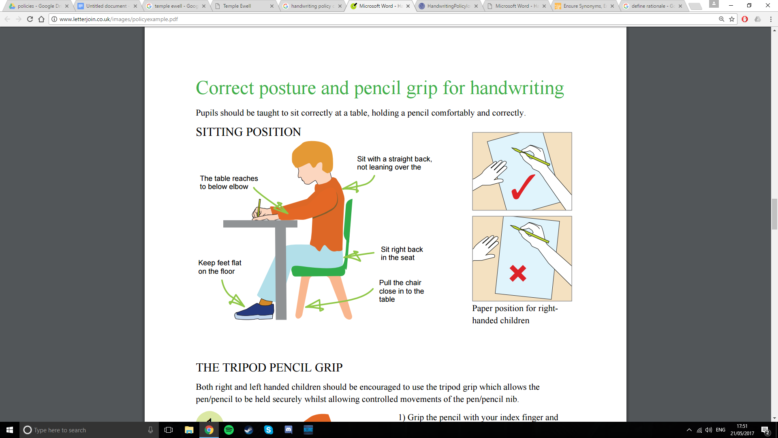**Posture:**

**Pencil grip:**

Children should write with a pencil (or pen as soon as a neat cursive script has been developed and pen license has been earned) with a rounded nib. Pencils should be reasonably sharp. A tripod grip is the most efficient way of holding a pencil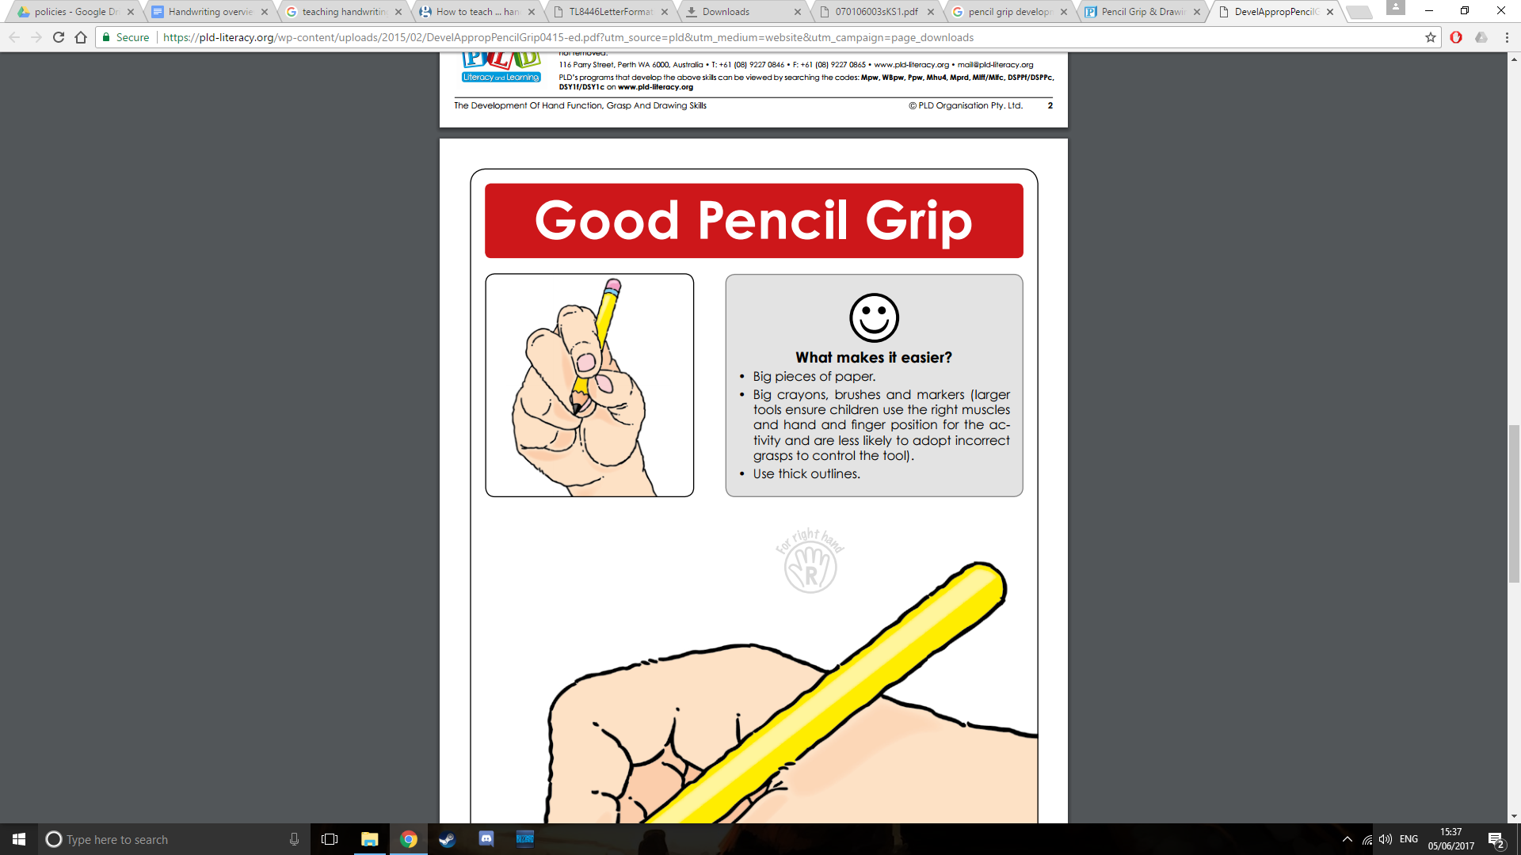

***For right handers:***

Hold lightly between thumb and forefinger resting on the first knuckle of the middle finger.

Hold about 3cm from the tip.

Use the left hand to steady the paper.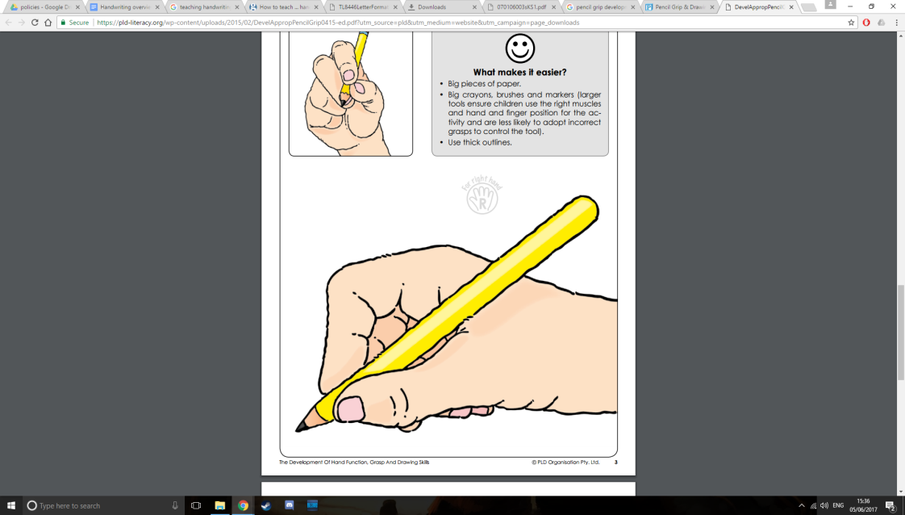

***For left handers:***

Hold lightly between thumb and forefinger resting on the first knuckle of the middle finger.

Hold about 3cm from the tip.

The hand should be kept below the writing line.

Use right hand to steady the paper.

**Cursive script rules:**

1. All letters start on the line.
2. The body of the letter sits on the line.
3. All similar letters are the same height.
4. All down strokes are straight and parallel.
5. All rounded letters are closed.
6. Letters which finish at the top join horizontally.
7. Letters which finish at the bottom join diagonally.
8. Each letter should be written in one flowing movement.
9. Each word should be written in one flowing movement.
10. Letters within a word should be evenly spaced.
11. Capital letters do not join to lower case letters. Capital letters remain in the basic style.

The rules of cursive style help to prevent initial confusion as every letter leads out with an exit stroke. Letters naturally flow into each other, so it is easier to join. Children develop an awareness of the whole word, which helps with the child’s visual memory and aids a grasp of spelling rules and common letter strings. Cursive writing will help with all children’s writing skills regardless of academic ability.

The British Dyslexia Association notes that the continuous flow of cursive ultimately improves writing speed and spelling and helps dyslexics with easily confused letters such as “b,” “d,” “p,” and “q.” Dyslexic children are also able to distinguish between uppercase and lowercase letters better. Because their writing hands develop a physical memory of the letters, dyslexics are better able to consistently and correctly reproduce the shapes.