Rabbits Home Learning
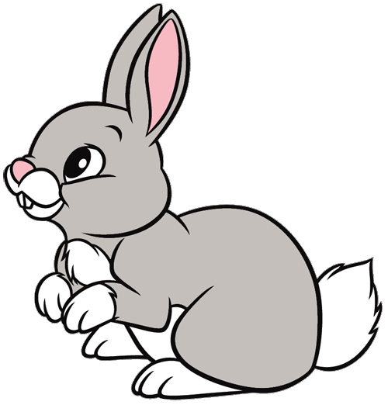
Friday 23rd April
This term we are learning about growing.
Have a look in your garden or in the park. What can you see that is growing?
Make a picture of something growing…. Plants, trees or flowers. You can draw, make or paint. We’d love to add your creations to our display board.
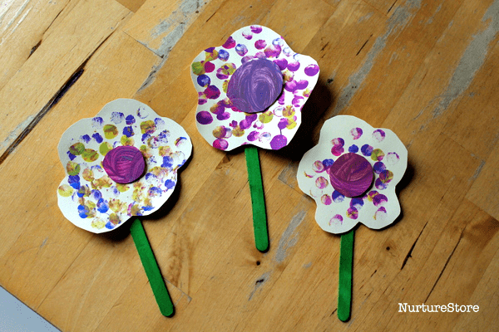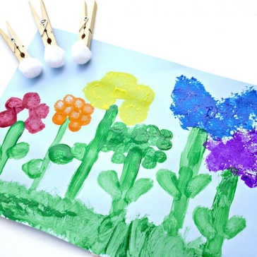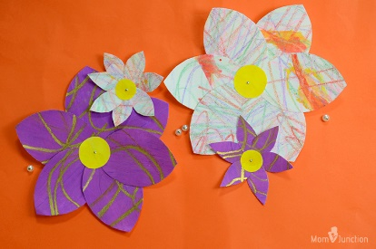
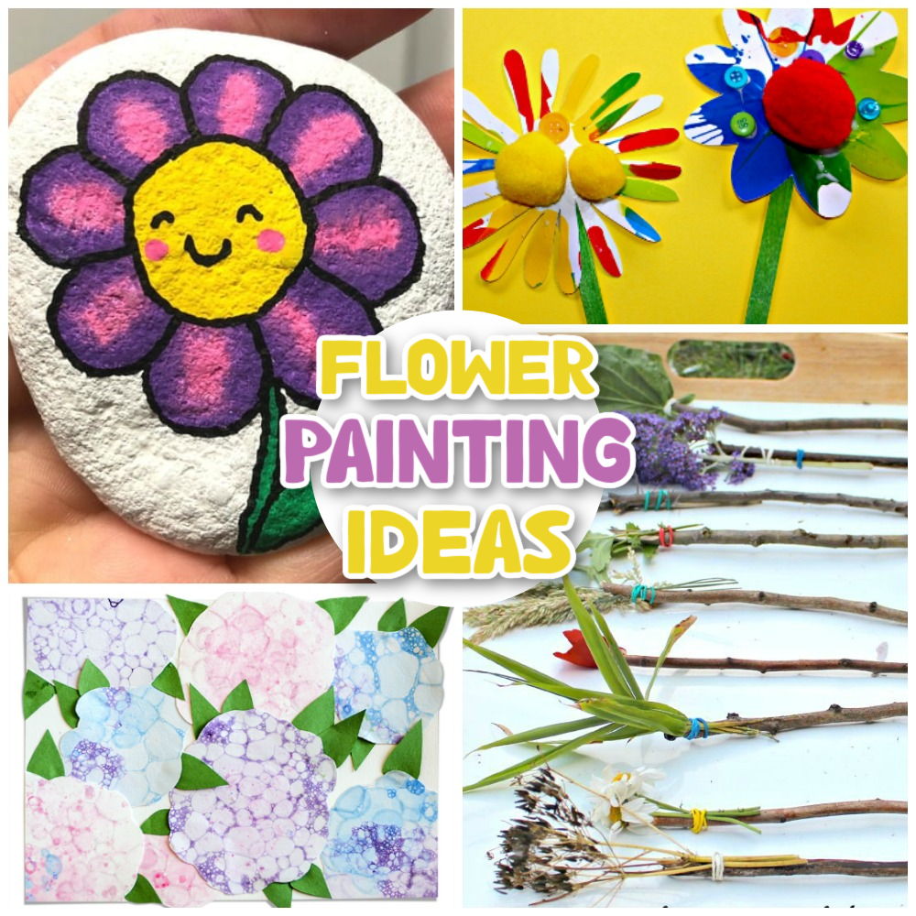
In Maths this week we have been learning about numbers to 20 and beyond.
The children love this Spiderman counting song….
https://www.youtube.com/watch?v=L9md4L2pAVQ

