Rabbits Home Learning

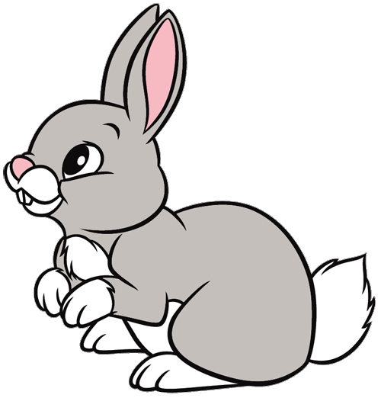

Friday 30th April

Can you make numerals 1-10 or 1-20 using natural materials?

Try to make a number line in order.

Please take photos and send them to me or print them and stick them in your book.

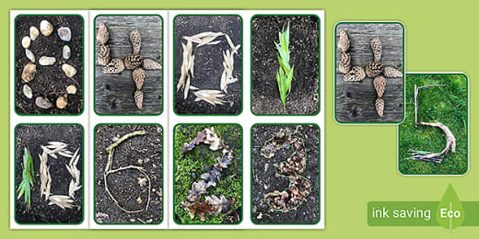

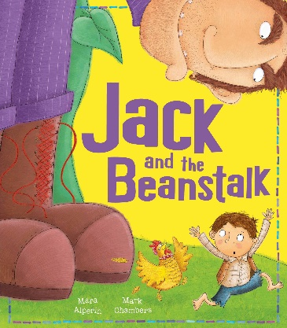 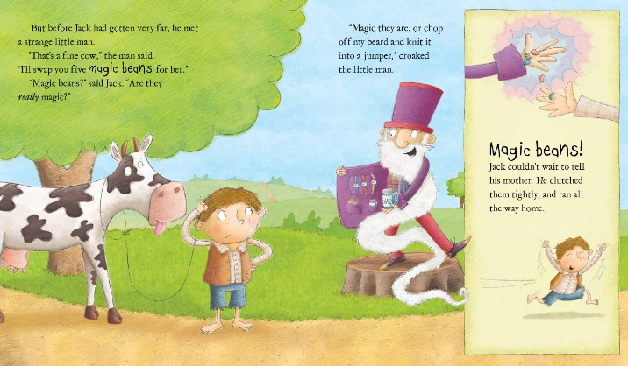

Can you retell the story of ‘Jack and the Beanstalk’ to an adult at home? Can you remember what the giant says?

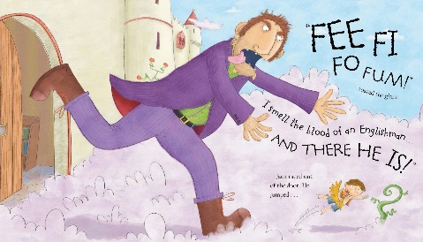 What happens at the end of the story?