Spellings – (Mrs Siddiqui’s group)
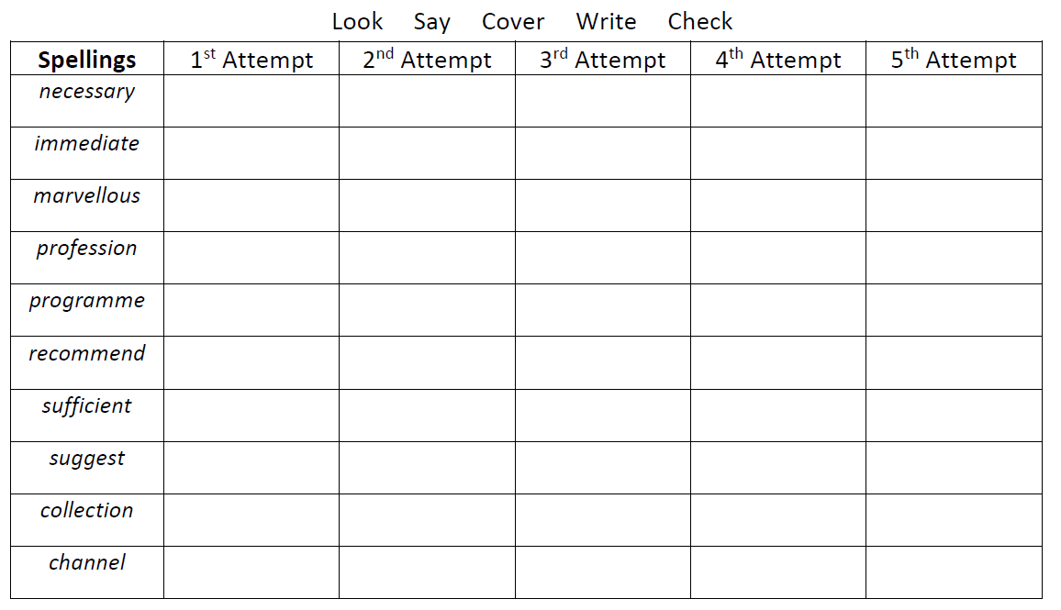
English spellings
Afghanistan, deportation (ed), refugee, immigration, Hazara, Taliban, Cambridge

Mrs Bird’s Group
 | 1st Attempt | 2nd Attempt | 3rd Attempt | 4th Attempt | 5th Attempt
enough
rough
cough
thought
bought
brought
through
tough

