Spellings – (Mrs Siddiqui’s group)
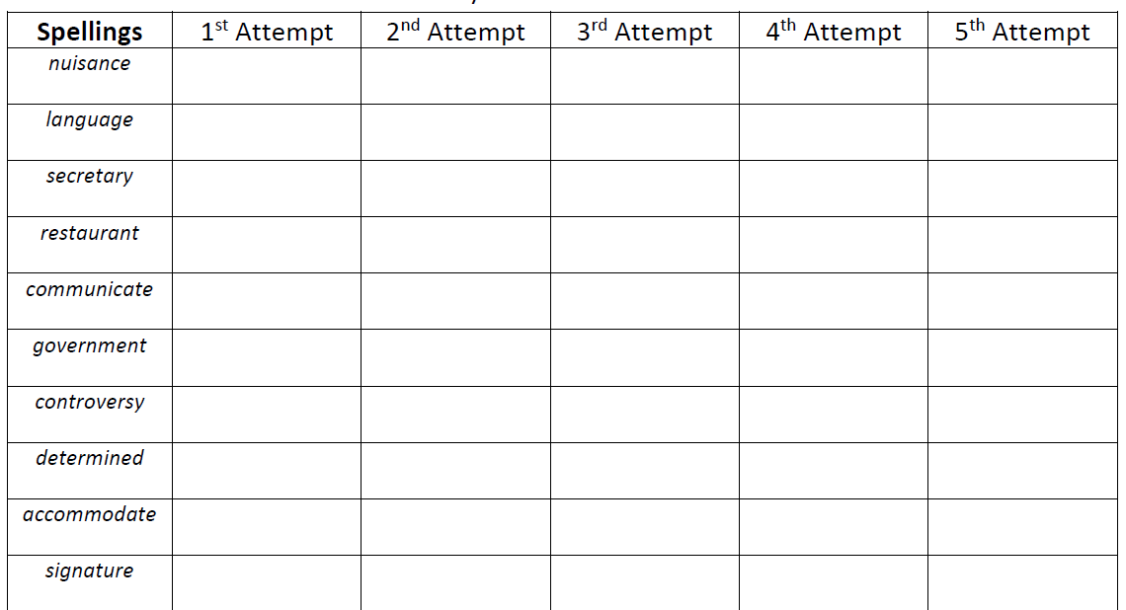

Mrs Bird’s Group
 | 1st Attempt | 2nd Attempt | 3rd Attempt | 4th Attempt | 5th Attempt
perhaps
probably
promise
possible
important
difficult
different
accident
appear
disappear

