Homework – 23.04.2021
Topic:
For Geography this term, we are looking in detail at the local area. So far the children have discussed how they travel to school and what towns and villages they live in.
As part of the National Curriculum, the children need to be able to tell someone their address. They have learnt how an address works and so their activity today will be to sit down with their adult and write down their address.
Can you explain what each line of the address means?

__________________________________________________________________________________________________________________________________________________________________________________________________________________________________________________________________________________________________________________________________________________________________

Maths:
This week the children have been doing recap work, looking at place value within 50. Please complete the questions below.
Year 1:
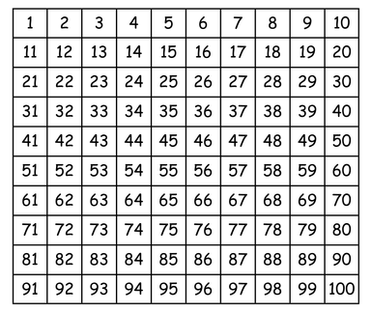
Please use the hundred square below to find one more and one less.
1. a) One more than 27 = ________
b) One less than 45 = _______
c) One more than fourteen = ________
d) One less than twenty-three = _________

2. Can you work out the numbers of the objects below?
a)
= _________________

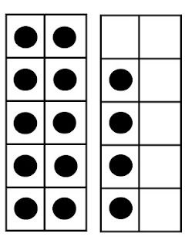
b)
= _________________

c)
= _________________

3. Can you partition these numbers into tens and ones?
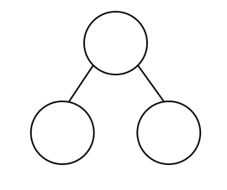
a) b)
34
24

Year 2:
1. a) Two more than 29 = ________
b) Six less than 100 = _______
c) Two more than fourteen = ________
d) Three less than eighty-seven = _________

2. Can you work out the numbers of the objects below?
a)
= _________________

b)
= _________________

c)
= _________________

3.
a) b)
21
62
18
38

